Data Definition Language (DDL)
When you are manipulating the structure of a database, there are three main elements that you will work with, tables, indexes and relationships.
- Tables are the database objects that contain the physical data, and they are organised by their columns and rows, identified in Ms Access as fields and records.
- Indexes are the database feature that defines how the data in the table is arranged and sorted in memory.
- Relationships define how two or more tables relate to one another.
These three elements are common to all relational databases.
Using DDL, you create, run and test database objects in MS Access with its Jet Special Query language (SQL) editor that is located with the QBE (Query by Example) engine, in SQL view. In other words, you open a new Query to enter the Jet SQL editor, and the SQL program statement is saved as a Query object.

Creating and Deleting Tables
Tables are the core building blocks of the relational database. A table contains rows of data, and each row is organised into a finite number of columns that contain the respective fields of these records. To build a new table in MS Access, you must name the table, name the columns, and define the types of data that the columns will contain. This is done with the CREATE statement in SQL. Let’s suppose we are creating an Invoicing database, and we start by building the Customer table.

CREATE TABLE tblCustomers
(Customer-ID INTEGER,
[Last Name] TEXT (50),
[First Name] TEXT (50),
Phone TEXT (10),
Email TEXT (50))

Note:
- If a column name contains a space or some other non-alphanumeric character, then it must be enclosed in square brackets.
- The limited range of column types, e.g. Text, Integer, etc., are those found in MS Access Table design, and not all are common to every version of SQL. For more information, search on SQL data types in the Office Assistant or the Answer Wizard in the Help window
- If you do not declare a length, – number of characters -, for text columns, they will default to 255 characters. For consistency and code readability, you should always define your column lengths.

Column Declaration Constraints
You can declare a column to be NOT NULL, which means a value must always be entered in that column for every record in the table. It cannot be left empty. This should not be confused with, for example, holding a value of zero.

CREATE TABLE tblCustomers
(Customer-ID INTEGER NOT NULL,
[Last Name] TEXT (50) NOT NULL,
[First Name] TEXT (50) NOT NULL,
Phone TEXT (10),
Email TEXT (50))

Delete a Table
To remove/delete a Table from the database, use the DROP TABLE statement in SQL

DROP TABLE tblCustomers

Working with Indexes
An index is an external data structure used to sort or arrange pointers in a table. When you apply an index to a table, you are specifying a certain arrangement of the data so it can be accessed more quickly. However, if you apply too many indexes to a table,
- You many slow down the performance because there is an extra overhead involved in maintaining the index.
- An index can cause locking issues when employed in a multi-user environment.
But used in the correct context, an index can greatly improve the performance of an application.
To build an index on a table, you must name the index, name the table to build the index on, name the column or columns within the table to which indexing is applied, and name the options you want to use.

Create Table Index(es)
You use the CREATE INDEX statement in SQL to build the index. For example, with our Customer table in the Invoice database:

CREATE INDEX idxCustomerID
ON tblCustomers (CustomerID)

Indexed columns can be sorted in either ascending (ASC) or descending (DESC) order. Sorting an Integer column in ascending order, the data is sorted from 1 to 100, and in descending order from 100 to 1. You should declare the sort order for each column in the index. The default order is ascending, and it does not have to be declared.

CREATE INDEX idxCustomerID
ON tblCustomers (CustomerID DESC)
There are four main options you can use with an Index, PRIMARY, DISALLOW NULL, IGNORE NULL, and UNIQUE.
- The PRIMARY option designates the indexed column as the primary key for the table. You can have only one primary key index per table, though the primary key index can be declared with more than one column, - compound and composite primary keys. You should use the WITH keyword in SQL to declare the index options.

CREATE INDEX idxCustomerID
ON tblCustomers (CustomerID DESC)
WITH PRIMARY

To create a primary key on more than one column, list all the columns

CREATE INDEX idxCustomerID
ON tblCustomers ([first name], [last name])
WITH PRIMARY

- The DISALLOW NULL option prevents the inclusion of null data in the column. This operates in similar fashion to the NO NULL declaration in the CREATE TABLE statement.

CREATE INDEX idxCustomerEmail
ON tblCustomers (Email)
WITH DISALLOW NULL

- The IGNORE NULL option causes null data in the indexed column to be ignored for the index. This means that any record with a null value in the indexed column will not be used, or counted, in the index.

CREATE INDEX idxCustomerLastname
ON tblCustomers ([Last Name])
WITH IGNORE NULL

- The UNIQUE option means that only unique, non-repeating values can be inserted into the indexed column.

CREATE UNIQUE INDEX idxCustomerPhone
ON tblCustomers ([Last Name])

Remove Table Index

To remove an Index from a table, use the DROP INDEX statement in SQL

DROP INDEX idxName
ON tblCustomers

Defining Relationships between Tables
Relationships are the established associations between two or more tables. Relationships are based on common fields in associated tables, - the only acceptable redundancy within the structure of a conventional relational database -, either primary or foreign keys.
A primary key is the field or fields used to uniquely identify each record in a table. There are three requirements for a primary key. It cannot be null, it must be unique, and there can only be one defined per table.
You can define a primary key by:
- Creating a primary key Index after the table is created.
- Using the CONSTRAINT clause in the column declaration when creating the table. The constraint clause limits the values that can be entered in the column.
- Using the PRIMARY KEY clause when creating a table, essential when the primary key is compound/composite, i.e. is more than one column.
A foreign key is the column or columns in one table that references the primary key in another table. The data format in the related columns from both tables must be exactly the same, in terms of type and size. The parent table must have existing records containing all the related column values before the associated (child) table can have matching or related records.
You can define a foreign key in the same ways as a primary key, as long as the parent table and its keys/indexes exists already.
There are three types of relationship:
- One-to-one: For every record in the parent table, there is one and only one record in the associated table.
- One-to-many: For every record in the parent table, there are one or more records in the associated table.
- Many-to many: For every record in the parent table, there are many related records in the associated table, and vice versa.
For example, lets add an Invoice table to our Invoicing database. Every customer in our Customers table can have many invoices in our Invoice table, a classic one-to-many relationship. We will take the primary key from the Customers table and define it as the foreign key in the Invoices table, thereby establishing a proper relationship between these tables.
When defining the relationship, the CONSTRAINT declarations must be made at the column level, within the CREATE TABLE statement.
CREATE TABLE tblInvoice
(InvoiceID INTEGER CONSTRAINT PK_InvoiceID PRIMARY KEY,
CustomerID INTEGER NOT NULL CONSTRAINT FK_CustomerID
REFERENCES tblCustomers.CustomerID,
InvoiceDate DATETIME,
Amount CURRENCY;

Note:
- The Primary key index (PK_InvoiceID) for the Invoices table is declared within the CREATE TABLE statement. Indexes are automatically generated for Primary keys, so there is no need for a separate CREATE INDEX statement.
Now let’s create a Shipping table that will contain each Customers shipping address. We will assume there is just the one Shipping address (record) per Customer (record), so we will be establishing a one-to-one relationship.
CREATE TABLE tblShipping
(CustomerID INTEGER CONSTRAINT PK_CustomerID PRIMARY KEY,
REFERENCES tblCustomers.CustomerID,
Address TEXT(50),
Town TEXT(50),
County TEXT(15),
PostCode TEXT(8);

Note:
- The CustomerID acts as both the Primary Key for this tblShipping table and its Foreign Key reference to the tblCustomer table.
- In this context, the realisation of SQL statements in MS Access does not map exactly to the DDL statements;
It is preferable for Primary and Foreign keys to be established with PRIMARY KEY and FOREIGN KEY clauses at the end of the Statement, rather than with CONSTRAINT clauses at the Column level. It is the only way to do it if Primary and Foreign keys comprise more than one column, i.e. they are compound/composite keys. The syntax is very similar.
Here the Primary key is shown declared at the column level and the Foreign key in a (CONSTRAINT) clause at the end of the Statement.
CREATE TABLE tblShipping
(CustomerID INTEGER PRIMARY KEY,
Address TEXT(50),
Town TEXT(50),
County TEXT(15),
PostCode TEXT(8),
FOREIGN KEY (CustomerID REFERENCES Customer.CustomerID));
When you are creating a relationship within a CREATE TABLE statement, it is assumed the relationship is one-to-many, with tblCustomers as the parent table, and not one-to-one.
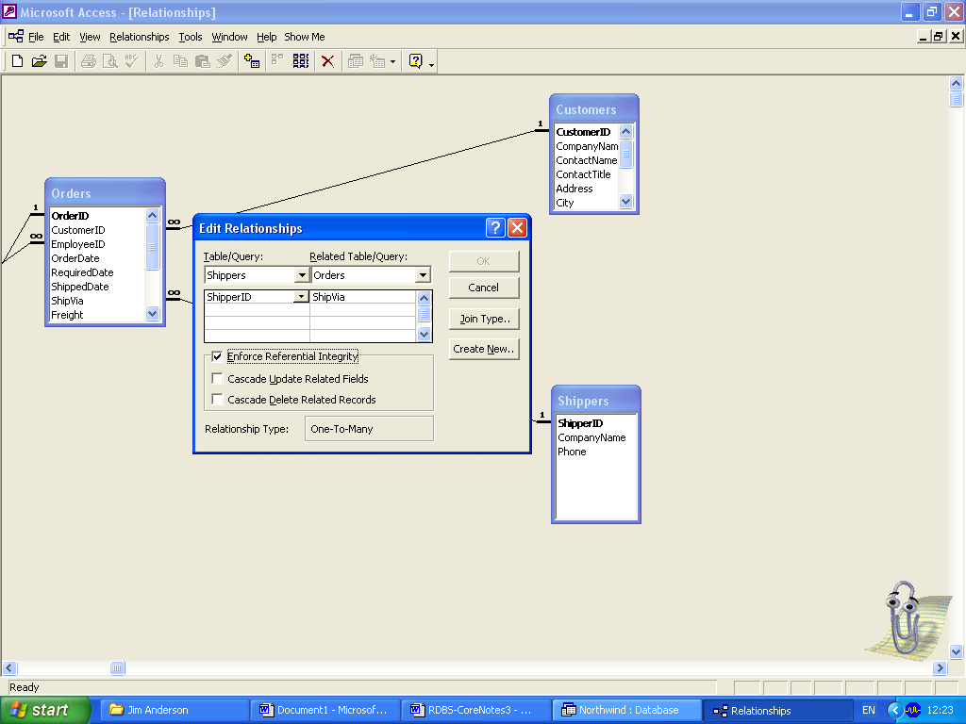
To modify the relationship to being one-to-one, open Relationship view, if necessary add the new table to the view, click on the tblCustomer relation line to tblShipping with the right mouse button and select Edit Relationship. In the Edit dialogue box select Join Type button, make the appropriate selection, and press OK twice to exit the two dialogue boxes.

Data Manipulation Language

SELECT ... FROM
What do we use SQL for? Well, we use it to select data from the tables located in a database. Immediately, we see two keywords: we need to SELECT information FROM a table. Hence we have the most basic SQL statement structure:

SELECT "column-name" FROM "table-name"

To illustrate this, assume we have the following table, which we will use throughout this section:

Table Store-InformationStore-name | Sales | Date
 | Los Angeles | $1500 | Jan-05-1999
 | San Diego | $250 | Jan-07-1999
 | Los Angeles | $300 | Jan-08-1999
 | Boston | $700 | Jan-08-1999
SELECT [Store-name] FROM [Store-Information]

The outcome is:Store-name
Los Angeles
San Diego
Los Angeles
Boston

Note. Multiple column names can be selected, as well as multiple table names.

DISTINCT
The SELECT keyword allows us to grab all the field values from a column or columns in a table. This, of course, may mean that there will be some redundancy. What if we only want to select each distinct value just the once? All we need to do is to add DISTINCT after SELECT. The syntax is as follows:

SELECT DISTINCT "column-name" FROM "table-name"

For example, to select all stores just the once from table Store-Information,

SELECT DISTINCT [Store-name] FROM [Store-Information]

The outcome is:Store-name
Los Angeles
San Diego
Boston

WHERE
We might want to conditionally select the data from a table. For example, we may want to only retrieve stores with sales above $1,000. To do this, we use the WHERE keyword. The syntax is as follows:

SELECT "column-name"
FROM "table-name"
WHERE "condition"

For example, to select all stores with sales above $1,000 in table Store-Information,

Table Store-InformationStore-name | Sales | Date
 | Los Angeles | $1500 | Jan-05-1999
 | San Diego | $250 | Jan-07-1999
 | Los Angeles | $300 | Jan-08-1999
 | Boston | $700 | Jan-08-1999
We key in,

SELECT Store-name
FROM Store-Information
WHERE Sales > 1000

The outcome is:Store-name
Los Angeles

Function SUM
Since we have started dealing with numbers, the next question we ask, is it possible to do math on those numbers such as summing up or taking the average. The answer is yes! SQL has several arithmetic functions, among them SUM and AVG. The syntax for this is,

SELECT "function-type"("column-name")
FROM "table-name"

For example, if we want to get the sum total of all sales from our sample table, we would key in

SELECT SUM(Sales)
FROM Store-Information
The outcome is:Sum (Sales)
$2750
Where $2750 is the Sum-Total of the Sales figures

Function COUNT
Another arithmetic function is COUNT. This allows us to COUNT up the number of row in a certain table. The syntax is,

SELECT COUNT("column-name")
FROM "table-name"

For example, if we want to find the number of Store entries in our table,

Table Store-InformationStore-name | Sales | Date
 | Los Angeles | $1500 | Jan-05-1999
 | San Diego | $250 | Jan-07-1999
 | Los Angeles | $300 | Jan-08-1999
 | Boston | $700 | Jan-08-1999
We key in,

SELECT COUNT(Store-name)
FROM Store-Information

The outcome is:COUNT(Store-name)
4

COUNT and DISTINCT can be used together in a statement to fetch the number of distinct entries in a table. For example, if we want to find out the number of distinct stores, we would key in,

SELECT COUNT (DISTINCT Store-name)
FROM Store-Information

The outcome is:COUNT(DISTINCT Store-name)
3

Aggregate Function GROUP BY
Now we return to aggregate functions. Remember we used the SUM keyword to calculate the total sales for all stores. If we want to calculate the total sales for each store, we need to do two things: First, we make sure we select the store name as well as total sales. Second, we make sure all the sales figures are grouped by stores. The corresponding SQL syntax is,

SELECT "column-name1", SUM("column-name2")
FROM "table-name"
GROUP BY "column-name1"

Table Store-InformationStore-name | Sales | Date
 | Los Angeles | $1500 | Jan-05-1999
 | San Diego | $250 | Jan-07-1999
 | Los Angeles | $300 | Jan-08-1999
 | Boston | $700 | Jan-08-1999
If we key in:
SELECT [Store-name], SUM(Sales)
FROM [Store-Information]
GROUP BY [Store-name]

The outcome is:Store-name | SUM (Sales)
 | Los Angeles | $1800
 | San Diego | $250
 | Boston | $700

With the two Sales figures of $1500 and $300 for Los Angeles accumulated to $1800

The GROUP BY keyword is used when we are selecting multiple columns from a table or tables and at least one arithmetic operator appears in the SELECT statement. When that happens, we need to GROUP BY all the other selected columns, i.e., all columns except the one(s) operated on by the arithmetic operator.

Aggregate Function HAVING
We may want to limit the output based on the corresponding sum or any other aggregate functions. For example, we might want to see only the stores with sales over $1,500. Instead of the WHERE clause, we use the HAVING clause reserved for aggregate functions. The HAVING clause is typically placed near the end of an SQL statements, and may or may not include the GROUP BY clause. The syntax is,

SELECT "column-name1", SUM("column-name2")
FROM "table-name"
GROUP BY "column-name1"
HAVING (arithmetic function condition)

If we keyed in

SELECT [Store-name], SUM (Sales)
FROM [Store-Information]
GROUP BY [Store-name]
HAVING SUM(Sales)>1500

The outcome is:Store-name | SUM (Sales)
 | Los Angeles | $1800

ALIAS
There are two types of aliases used frequently:
- Column aliases exist to help organise output. Whenever we saw total sales previously, it was listed as SUM(Sales). While it is comprehensible, we can envisage cases where the column heading is complex, especially if it involves several arithmetic operations. Using a column alias makes the output much more readable.

- Table aliases are convenient when you want to obtain information from two separate tables, - perform joins -. This is accomplished by putting an alias directly after the table name in the FROM clause. The SQL syntax is,

SELECT "table-alias"."column-name1" "column-alias"
FROM "table-name" "table-alias"

Both types of aliases are placed directly after the item they are the alias for, separate by a white space.

Table Store-InformationStore-name | Sales | Date
 | Los Angeles | $1500 | Jan-05-1999
 | San Diego | $250 | Jan-07-1999
 | Los Angeles | $300 | Jan-08-1999
 | Boston | $700 | Jan-08-1999
If we key in:
SELECT A1.[Store-name] Store, SUM(A1.Sales)
FROM [Store-Information] A1
GROUP BY A1.[Store-name]

The outcome is:Store | Total Sales
 | Los Angeles | $1800
 | San Diego | $250
 | Boston | $700

Joins
Now we want to look at joins. To do joins correctly in SQL requires many of the elements we have introduced so far. Let's assume that we have the following two tables,

Table Store-Information |  |  |  | Table Geography
Store-name | Sales | Date |  | Region-name | Store-name
Los Angeles | $1500 | Jan-05-1999 |  | East | Boston
San Diego | $250 | Jan-07-1999 |  | Eat | New York
Los Angeles | $300 | Jan-08-1999 |  | West | Los Angeles
Boston | $700 | Jan-08-1999 |  | West | San Diego

We want to find out Sales by Region. The Geography table includes information on regions and stores, and Store-Information table provides the Sales for each Store. To obtain the sales information by region, we have to combine the two tables. Examining them both, we find they are associated by the related field, Store-name. In this example:

SELECT A1.Region-name REGION, SUM(A2.Sales) SALES
FROM Geography A1, Store-Information A2
WHERE A1.Store_name = A2.Store_name
GROUP BY A1.region_name

The outcome is:REGION | SALES
 | East | $700
 | West | $2050

The first two lines tell SQL to select two fields,
- Region-name (column alias REGION) from Geography (table alias A1),
- The SUM of Sales (column alias Sales) from Store-Information (table alias A2).
Without the aliases, the first line would become,
SELECT Geography.Region-name REGION, SUM(Store-Information.Sales) SALES
This is much more cumbersome. In essence, table aliases make the SQL statement much easier to understand, especially when multiple tables are involved.

Next, look at the third line, the WHERE statement specifying the condition of the join.
- We have to make sure the type and format for Store-name in Geography matches that in Store-Information, in order to ensure the WHERE statement runs correctly
- If the WHERE statement does not function properly, a Cartesian Join will result. A Cartesian Join here would cause the query to return every possible combination of the two tables in the FROM statement. In this case, a Cartesian Join would result in a total of four x four = sixteen rows being returned, instead of the two above.

SQL 4A Tutorial

Creating Tables
The create table statement is used to create a new table. Here is the syntax of a simple create table statement – square brackets denotes optional - :
CREATE TABLE "table-name"
("column1" "data type" [“constraint”],
"column2" "data type")[“constraint”]);
Note:
- It helps when checking and correcting, -debugging-, your SQL statement if you write all the key words in uppercase, e.g. CREATE and TABLE, and all other words in lowercase.
- You may declare as many columns as you like, each on a new line.
- The first column declaration must be preceded by the opening parenthesis, – bracket.
- As the constraints are optional, they are shown here in square brackets. When they are included, do not put them in square brackets.
- Separate each column declaration with a comma.
- The last line of this SQL statement is concluded by the closing parenthesis, - bracket -, then a semi-colon that is common to all SQL statements.
- The table and column names must start with a letter and can be followed by letters, numbers, or underscores/hyphens, and must not exceed a total of 30 characters in length. Do not use SQL reserved keywords such as SELECT, CREATE, etc., as names for tables or columns.
- Data types specify the type of data for that particular column, e.g. if a column holds names, then its data type is text. Search Access Help on SQL data types for more advice.
Example:
CREATE TABLE Employee
(First TEXT(15),
Last TEXT(20),
Age NUMBER,
Address TEXT(30),
City TEXT(20),
State TEXT(20));

Deleting Tables
The drop table statement is used to remove a table. The syntax of a simple drop table statement is:
DROP TABLE “table name”;

Authoring SQL Statements
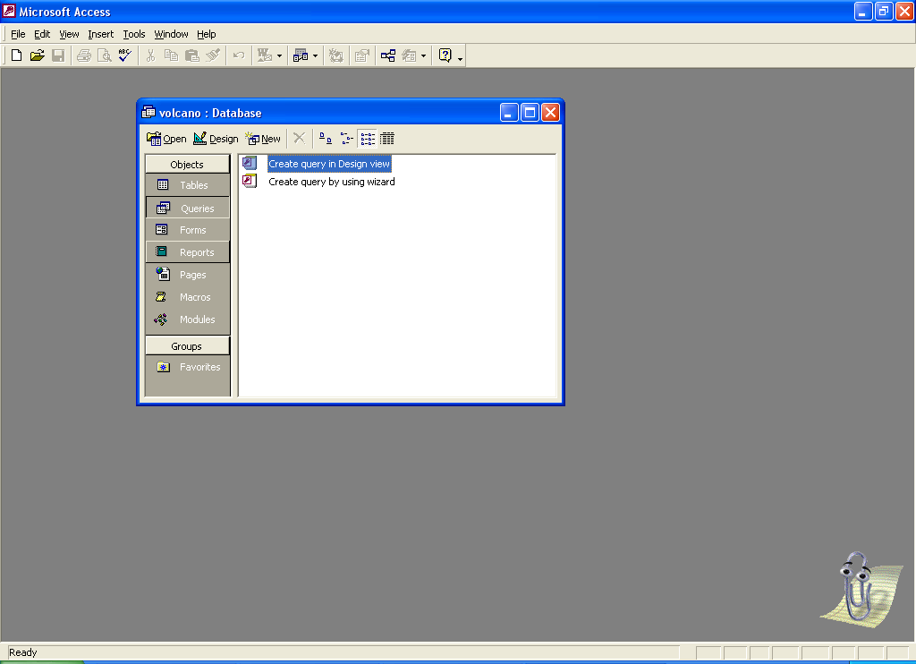
In MS Access database view,
select Objects

Queries
Open a new one with the
button, and

New
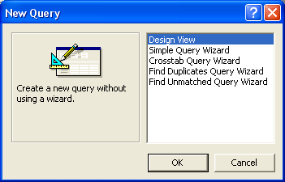
enter Design view
In Query Design view, transfer to SQL view
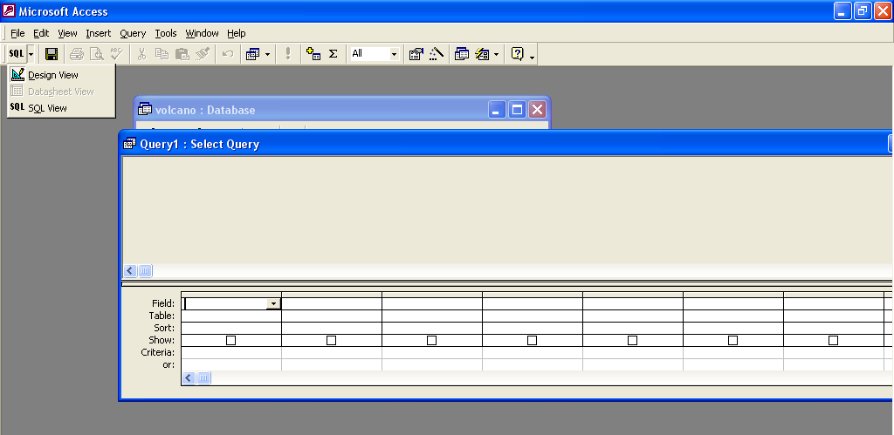

And key in your SQL statement
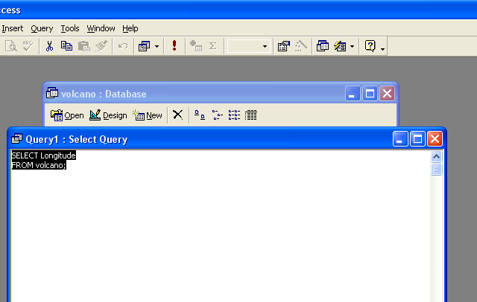
To run your statement, pull down the Query menu and select Run.
Except for Select statements, when you are automatically transferred to Query Dynaset view, where the outcome is displayed, there is no reaction.
Close and Save (As) the Query with a meaningful name that identifies its task and function, e.g. 4A Make Eruption Table.

Submission Of Evidence
For this outcome, you are required to submit, 1. A printout of the database structure, i.e. the Database Relationships view – select the Relations icon, once there ensure the page layout is landscape and File menu Print the database structure – this will transfer you to a Report Preview view, allowing you to save it as a Report – not required.
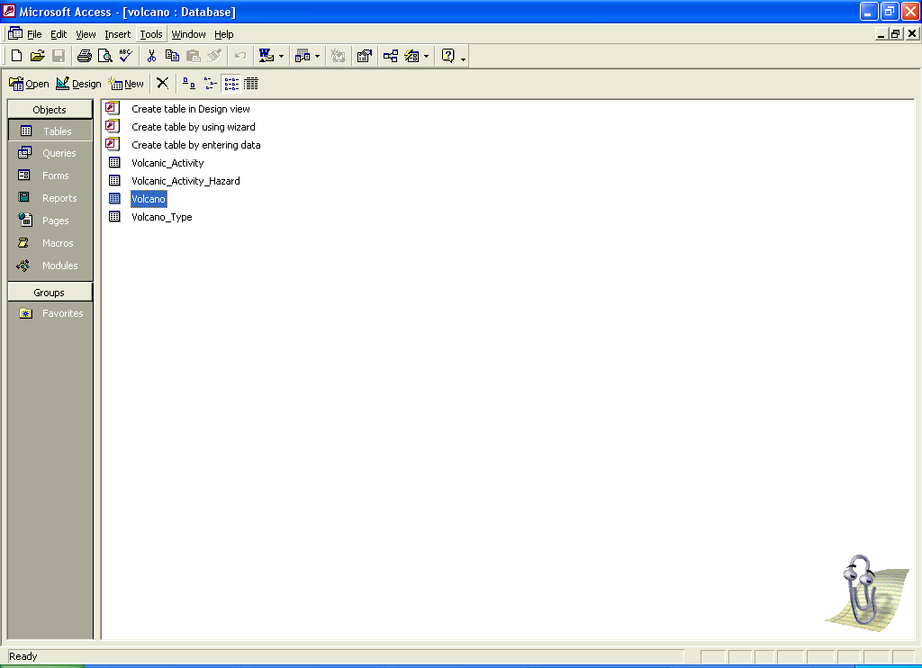

2. A printout of each Query’s– SQL Statement definition. Pull down the Tools menu, select Analyse…Documenter, and select the Query tab.

If the Documenter facility is not available to your station, the fall back position is to copy and past the SQL statement into a Word document, give it a suitable heading and print it from there. Do the same for a Query not displayed in the Documenter dialogue box, e.g. Delete Queries.

In Documenter view, you can print all the Query SQL definitions at one go, or singly. The Query or Queries must be selected by clicking into the white box(es) to the left of the listed names.
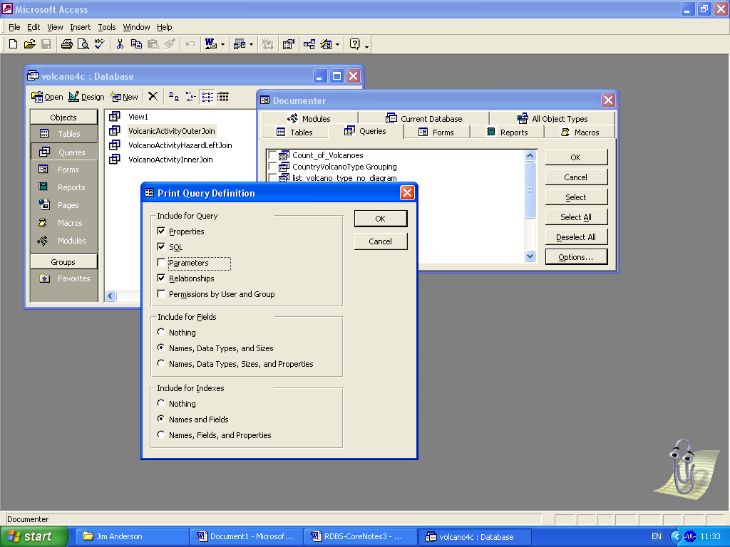
But, to avoid downing a rain forest, select the Options button, and make the selections shown here – if uncertain, ensure you do not select Query permissions or parameters, similarly you do not select Field or Index properties.
Exiting via both Ok buttons will transfer you to Print Preview – this may take some time, be patient.
At this point you could be aborted with an error message indicating that the definition cannot be generated. In nearly every case, this is because a Query has been left open, thus thwarting the Documenter. To print any database Object definition, the Object itself must be closed.
In Print Preview, carry out a visual check that (each) Query definition is less than a page, or no more than 2 pages, before selecting File menu Print.

Establish Keys and Relationships
To establish tables with primary keys and foreign key relationships, consider the database structure below:

MEMBER
Member No
Name
Address
Tel. No.
HIRE
Member No
Video No
Date Issued
Due Return Date
Actual Return Date
VIDEO
Video No
Title
Category

The following SQL statements should be used to create the 3 tables and their relationships, in the order given here, parent tables first:

CREATE TABLE Video
(Video_No NUMBER NOT NULL PRIMARY KEY,
Title TEXT(50),
Category TEXT(25));

CREATE TABLE Member
(Member_No NUMBER NOT NULL PRIMARY KEY,
Name TEXT(30),
Address TEXT(255),
Tel_No NUMBER);

CREATE TABLE Hire
(Member_No NUMBER NOT NULL,
Video_No NUMBER NOT NULL,
Date_Issued DATE NOT NULL,
Due_Return_Date DATE,
Actual_Return_Date DATE,
Category TEXT(25),
PRIMARY KEY (Member_No, Video-No, Date-Issued),
FOREIGN KEY (Member_No) REFERENCES Member,
FOREIGN KEY (Video_No) REFERENCES Video);

Note:
- When creating the associated Hire table, in which the relations are established, the Constraint clauses for keys are given at the end of the Statement.

SQL 4B Tutorial

Copying a Table or Part of a Table
Use the COPY command in order to copy matching columns from the source table into the copy table. The command sequence has the following syntax:
INSERT INTO “copy table”(copy-column-name1,copy-column-name2, ..)
SELECT (source-column-name1, source-column-name2, ...)
FROM “source table name”
Example:
INSERT INTO Part (Part-code, Part-desc, Part-price)
SELECT (P-code, P-desc, P-price)
FROM Product;

Note
- The syntax above allows data, of the same type, format, etc., to be copied between table columns of different names. But if the definitions of the respective columns must be identical for the COPY command statement to run successfully.
- When you want to copy a table, which obviously has to have a new name, create it using a suitably modified version of the CREATE TABLE statement for the source table. This ensures their respective column definitions are identical. You then can run a much-simplified version of the COPY command, using the SQL wildcard * (asterisk).
INSERT INTO “copy table name”
SELECT * FROM “source table name”;

Making a Correction
Use the UPDATE command to make data entry corrections. The command sequence has the following syntax:
UPDATE “table name”
SET (“first-column-name” = value1,”second-column-name” = value2,)
WHERE “column name” = value;
Example:
UPDATE Product

SET Pin-date = ‘18/01/2003’
WHERE P-code = 1234;

Entering New Rows
Use the INSERT command to add new rows. The command has the following syntax:
INSERT INTO “table name”
(first-column-name, second-column-name, ..,last-column-name)
VALUES (first-value, second-value, ..,last-value)
Example:
INSERT INTO Employee (First name, Last name, Age)
VALUES (‘Scott’, ‘Howie’, 23);
Note: All values except for numbers are put in ‘single quotes’.

Deleting Table Rows
Use the DELETE command to delete a table row, either permanently or as part of a sequence to make data entry corrections. It has the following syntax:
DELETE FROM “table name”
WHERE “column name” = value;
Example
DELETE FROM Product
WHERE Part-Code = 1234;

Altering Tables
After you create and populate a table, you may need to modify its design. You do this with the ALTER TABLE statement. But be warned, altering a table structure:
May cause you to loose some of the data. For example, changing a column definition, e.g. data type, can result in the loss of all its data or in rounding errors, depending on the data types you are using.
Can break other parts of your application that refer to this table and its column(s). Be extra cautious when modifying a table, and check its associations carefully.
The statement enables you to add, remove, or change a column, and add or remove a constraint. You can also declare a default value for a column. But you can alter only one column at a time. With our old friend the Invoicing database:
To add a column to the Customers table, use the ADD COLUMN clause with the name of the column, its data type, and its size if required.
ALTER TABLE tblCustomers
ADD COLUMN Address TEXT(30);
- To change the data type or size of a column, use the ALTER COLUMN clause with the name of the column, its data type, and its size if required.
ALTER TABLE tblCustomers
ALTER COLUMN Address TEXT(30);
- To change the name of a column, you have to remove it and then insert a new column with the new name. To remove a column, use the DROP COLUMN clause with the field name only.
ALTER TABLE tblCustomers
DROP COLUMN Address;
But this command permanently eliminates the existing data in the column. To preserve the data contents, copy it to a column in a temporary table and then Copy it back to the re-named column.

A default value is a value entered in a column when a new row is added to a table and no value is specified for that particular column. To set a default value for a column, use the DEFAULT keyword in the ADD COLUMN or ALTER COLUMN clause.

ALTER TABLE tblCustomers
ALTER COLUMN Address TEXT(40) DEFAULT Unknown;

SQL 4C Tutorial

Selecting Data
The select statement is used to query the database and retrieve selected data, which matches the criteria that you specify. Here is the syntax of a simple select statement – note, square brackets denotes optional -:
SELECT "first column name"[,"second column name, etc.]
FROM "table name"
[WHERE "condition"];
Note:
- The column names that follow the SELECT keyword determine which columns will be returned in the results. You can select as many columns as you like, or you can use the * (asterisk) wildcard to select all columns.
- The table name that follows the keyword from specifies the table that will be queried to retrieve the desired results.
- The where clause (optional) specifies which data values or rows will be returned or displayed, based on the criteria described after the keyword where.
Conditional operators used in the where clause
= | Equal to
 | > | greater than
 | < | Less than
 | >= | greater than or equal to
 | <= | Less than or equal to
 | <> | Not equal to
 | LIKE | very powerful operator that allows you to select rows that are "like" what you specify. The * (asterisk) can be used to match any possible character that might appear before or after the characters specified - see below.
SELECT first, last, city
FROM employee
WHERE first LIKE 'Er*';
Would return

Sample Employee table for Like conditional operator examples
first | last | id | age | city | state
John | Jones | 99980 | 45 | Payson | Arizona
Mary | Jones | 99982 | 25 | Payson | Arizona
Eric | Edwards | 88232 | 32 | San Diego | California
Mary Ann | Edwards | 88233 | 32 | Phoenix | Arizona
Ginger | Howell | 98002 | 42 | Cottonwood | Arizona
Sebastian | Smith | 92001 | 23 | Gila Bend | Arizona
Gus | Gray | 22322 | 35 | Bagdad | Arizona
Mary Ann | May | 32326 | 52 | Tucson | Arizona
Erica | Williams | 32327 | 60 | Show Low | Arizona
Leroy | Brown | 32380 | 22 | Pinetop | Arizona
Elroy | Cleaver | 32382 | 22 | Globe | Arizona

First | Last | City
Eric | Edwards | San Diego
Erica | Williams | Show Low

SELECT first, last,
FROM employee
WHERE last LIKE '*s';
Would return
First | Last
John | Jones
Mary | Jones
Eric | Edwards
Mary Ann | Edwards
Erica | Williams

SELECT * FROM employee WHERE first = 'Eric';
Would return
First | Last | Id | age | city | state
Eric | Edwards | 88232 | 32 | San Diego | California

GROUP BY clause
The GROUP BY clause will gather all of the rows together that contain data in the specified column(s) and will allow aggregate functions to be performed on the one or more columns. The syntax is:
SELECT “column name(s)”, FUNCTION(“column name”)
FROM “table name”
GROUP BY “column name(s)”;
Let's say you want to retrieve a list of the highest salaries in each department:
SELECT MAX(salary), department
FROM employee
GROUP BY department;
This statement will group the rows by department, select the largest salary from each department group, and will display this salary and the department name for each group
If you wanted to display the person’s last name as well, the statement would read
SELECT MAX(salary), department, lastname
FROM employee
GROUP BY department;

Similarly, for an items-ordered table, let's say you want to group everything of quantity 1 together, everything of quantity 2 together, everything of quantity 3 together, etc. If you want to determine what the largest cost item is for each grouped quantity (all quantity 1's, all quantity 2's, all quantity 3's, etc.), you would enter:

SELECT quantity, MAX(price)
FROM items-ordered
GROUP BY quantity;

Table Joins – the essence of relational database searches
All of the queries up until this point have been useful with the exception of one major limitation - that is, you've been selecting from only one table at a time with your SELECT statement. It is time to introduce you to one of the most beneficial features of SQL & relational database systems - the Join. To put it simply, the Join makes relational database systems relational.
- Joins allow you to link data from two or more tables together into a single query outcome, from the one single SELECT statement.
- A Join can be recognized from a SQL SELECT statement if it has more than one table after the FROM keyword.
For example:
SELECT “column name(s)”
FROM “table names”
WHERE “join condition(s)”;

Joins can be explained easier by demonstrating what would happen if you worked with one table only and didn't have the ability to use Joins. This single table database is often referred to as a flat table.
Let's say you have a one-table database that is used to keep track of all of your customers and what they purchase from your store. Every time a new row is inserted into the table, entries are made in all the columns, resulting in unnecessary -redundant data – being recorded. Typically, every time Wolfgang Schultz purchases something, the following rows will be inserted into the table:
Id | first | Last | Address | city | state | zip | Date | Item | price
10982 | Wolfgang | Schultz | 300 N. 1st Ave | Yuma | AZ | 85002 | 032299 | snowboard | 45.00
10982 | Wolfgang | Schultz | 300 N. 1st Ave | Yuma | AZ | 85002 | 082899 | Snow-shovel | 35.00
10982 | Wolfgang | Schultz | 300 N. 1st Ave | Yuma | AZ | 85002 | 091199 | Gloves | 15.00
10982 | Wolfgang | Schultz | 300 N. 1st Ave | Yuma | AZ | 85002 | 100999 | Lantern | 35.00
10982 | Wolfgang | Schultz | 300 N. 1st Ave | Yuma | AZ | 85002 | 022900 | Tent | 85.00

An ideal database would have two tables:
- One for keeping track of your customer information – customer-info
customer-number | First-name | Last-name | Address | City | state | zip
- And the other to keep track of what they purchase - purchases
customer-number | date | Item | price

Now, whenever a purchase is made from a regular customer, only the second purchases table needs to be updated! We've just eliminated useless redundant data, that is, we've just normalised this data structure!
Notice how both tables have a common customer-number column. This column, which contains the unique customer number will be used to JOIN the two tables. Using the two new tables, let's say you would like to select the customer's name, and items they've purchased. Here is an example of a join statement to accomplish this:
SELECT (customer-info.firstname, customer-info.lastname, purchases.item)
FROM (customer-info, purchases)
WHERE (customer-info.customer-number = purchases.customer-number);

Note
- This particular Join is known as an Inner Join or Equi-join. It is the most common type of Join used, and is the default Join for Access 2000.
- Each of the columns is preceded by the table name, separated by a period (full stop). This isn't always required, but it is strongly recommended as good practice so that you wont confuse which columns go with what tables. It is essential if column names are the same between the two associated tables called up by the same statement. I recommend preceding all of your columns with the table names when using joins.
- The syntax described above will work with most relational database systems.

For Outer Joins, or Left Joins, the SQL statement has the following syntax

SELECT (customer-info.firstname, customer-info.lastname, purchases.item)
FROM (customer-info LEFT JOIN purchases)
ON (customer-info.customer-number = purchases.customer-number);

Another example of an (Inner-)Join:

SELECT (employee-info.employeeid, employee-info.lastname,employee-sales.commission)
FROM (employee-info, employee-sales)
WHERE employee-info.employeeid = employee-sales.employeeid;

This statement will select the employee’s ID and last name from the employee-info table, and the commission value from the employee-sales table, for all rows where the employee’s ID in the two tables matches, i.e. for all employees who appear in both tables.

ORDER BY

ORDER BY is an optional clause that allows you to display the results of your query in sorted order, either ascending (ASC) – the default or undeclared order -, or descending (DESC), for the column(s) listed in the clause. The syntax is:

SELECT “column name(s)”, FUNCTION(“column name”)
FROM “table name(s)”
ORDER BY “column name(s)”[ASC|DESC];

Let's say you want to retrieve the employee-id, department, name, age, and salary from the employee-info table for employees in the sales department, and list the results in ascending (default) order of salary.
SELECT employee-id, department, name, age, salary
FROM employee-info
WHERE department = ‘Sales’
ORDER BY salary;

If you would like to order based on multiple columns, you must separate the columns with commas. For example:
SELECT employee-id, department, name, age, salary
FROM employee-info
WHERE department = ‘Sales’
ORDER BY salary, age DESC;

Aggregate Functions
MIN | returns the smallest value in a given column
MAX | returns the largest value in a given column
SUM | returns the sum of the numeric values in a given column
AVG | returns the average value of a given column
COUNT | returns the total number of values in a given column
COUNT(*) | returns the number of rows in a table

Aggregate functions are used to compute values from a column or columns of numeric data declared in a SELECT statement (note the one exception below). Basically they are used to summarise the results of a particular column of selected data. They are required for the GROUP BY clause, and can only used within such clauses, for example:
SELECT AVG(salary)
FROM employees;

This statement will return a single result, which contains the average value of all the values in the salary column from the employee table.
Another example:
SELECT AVG(salary)
FROM employees
WHERE title = ‘programmer’;
This statement will return the average salary for all employees whose title is equal to 'Programmer'
Example:

SELECT COUNT(*)
FROM employees;

This particular statement is the exception from the other aggregate functions. It does not compute values within a given column, it sums the number of occurrences it finds in the table, i.e. it provides a COUNT of the number of rows in the table.
You could have achieved the same by entering a NOT NULL column name in the brackets after the function.
Example:

SELECT COUNT(lastname)
FROM employees;

Access Rights
Since more than one user can access one database, there is a need to restrict individual users from using the entire database in any way they feel fit. Setting up access rights is the way to achieve this.
- Any right can be given to or removed from a user with the GRANT and REVOKE statements.
- Each right can be granted or revoked individually or to a defined group of users. Groups are identified by their ROLE, and rights can be granted or revoked in the same way as for individual users.

The GRANT and REVOKE statements
GRANT “statement of rights” ON “object name” TO “user name”[WITH ADMIN OPTION]
REVOKE “statement of rights” FROM “user name”
CREATE ROLE “ role name”
GRANT “statement of rights” ON “object name” TO “role name”[WITH ADMIN OPTION]
REVOKE “statement of rights” FROM “role name”
Note:
statement of rights | The rights to be granted or revoked, separated by commas
user name | The name of a user, to whom the rights will be granted or revoked.  Users in general are represented by the keyword PUBLIC.
role name | The name of a role to be granted or revoked rights.
Object name | The name of the object, table or view, on which the rights will be changed
WITH ADMIN OPTION | Gives administration rights on the object. i.e. a user with this right can grant rights, revoke rights, create role, change role and delete role.

Example database:
Album table holds information about audio CDs, each containing the songs from one album
Attribute name | Data type | Comment
Id | NUMBER | Primary key
Name | TEXT(80) | Name of the album
Interpreter | TEXT(80) | Name of the album's interpreter
Notes | TEXT | Any notes about the album
Released | DATE | The date the album has been released on
Song table holds information about songs on the albums/audio CDs.
Attribute name | Attribute data type | Comment
Id | NUMBER | Primary key
Album | NUMBER | Foreign key from table 'album'
Name | TEXT(80) | Name of the song
Notes | TEXT | Any notes about the song
Length | TIME | Song's length

Example 1
As you may noticed, the CD catalogue mainly consists of albums by the rock-‘n-roll king Elvis Presley. He, as the king, should have absolute rights granted to him, with his user name Elvis.
GRANT SELECT, INSERT, UPDATE, DELETE ON Album, Song TO Elvis WITH ADMIN OPTION

Example 2
As the database is accessed by the public at large, grant them only the SELECT right.

REVOKE INSERT, UPDATE, DELETE ON Album, Song TO PUBLIC

Example 3
Create a group of users, who can add and modify records, but not delete them.
CREATE ROLE editors
GRANT SELECT, INSERT, UPDATE ON Album, Song TO editors

Example 4
You have got new guy in your editor team and you want to authorize him to delete records. His user name is JBlack. Take advantage of editor privileges granted above.

GRANT editors, DELETE ON Album, Song TO JBlack

Example 5
Once again, you are left alone to maintain the CD catalogue, because all your co-workers have left are gone. Only the editors role remains and it is useless. Delete it.

DROP ROLE editors

When tables are created, it is common for one or more columns to have constraints associated with them. A constraint is basically a rule associated with a column that the data entered into that column must follow. For example, a UNIQUE constraint specifies that no two records can have the same value in a particular column. They must all be unique. The other two most popular constraints are NOT NULL, which specifies that a column can't be left blank, and PRIMARY KEY, which defines a unique identification of each row in a table.

