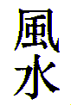

FENG SHUI

Feng Shui, Chinese for Wind and Water, also stands for the Secret of Happiness and Harmony Throughout One’s Life and Surroundings

-370-

