A TDG Executive Vignette ™

“Each person has inside a basic decency and goodness. If he listens to it and acts on it, he is giving a great deal of what it is the world needs most. It is not complicated but it takes courage. It takes courage for a person to listen to his own goodness and act on it."
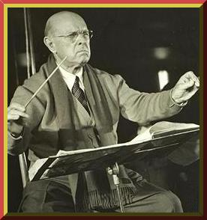

Pablo Casals, 1876-1973
Spanish Cellist, Conductor and Composer

-387-

