A TDG Executive Vignette ™

T'ai Chi
The T'ai Chi Meditative Movement
from T'ai Chi Classics
by Waysun Liao (ISBN: 0-87773-531-X)

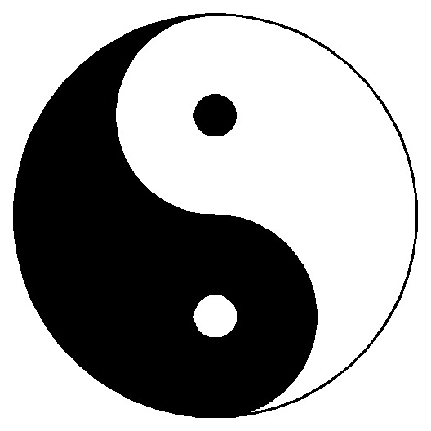
YANG | T'AI CHI | YIN
Heaven | Man | Earth
Parent | Adult | Child
Future | Present | Past
Sun | Day/Night | Moon
Body | Spirit | Mind
Physical | Feelings | Mental
Hard | Resilient | Soft
Upward | Centered | Downward
Flexed | Tonus | Relaxed
Expand | Pulsation | Contract
Right Brain | Whole Brain | Left Brain
Right Body | Whole Body | Left Body
Back Body | Whole Body | Front Body

What you begin to notice as you look at the above combinations is
that the Yin and Yang which make up the T'ai Chi can be seen as
a simple mathematical formula.

Yang + Yin = T'ai Chi

Yin + Yang = T'ai Chi
Expand, Yin + Contract, Yang = Pulsation

The equation only adds up if there is an equal amount of yin substance
and an equal amount of yang substance. When the two are equal, homeostatic balance is achieved.
-165-
© 1996 TDG, Inc. All rights reserved.

