A TDG Executive Vignette ™

What if you don't fit the Work/Process?

- change yourself

- change the work/process

- find others where you do

- communicate (learn, educate, etc.)

- make sure you do it well for the moment

- be a constructive "misfit" - a different view

- find a piece of the work/process that does fit

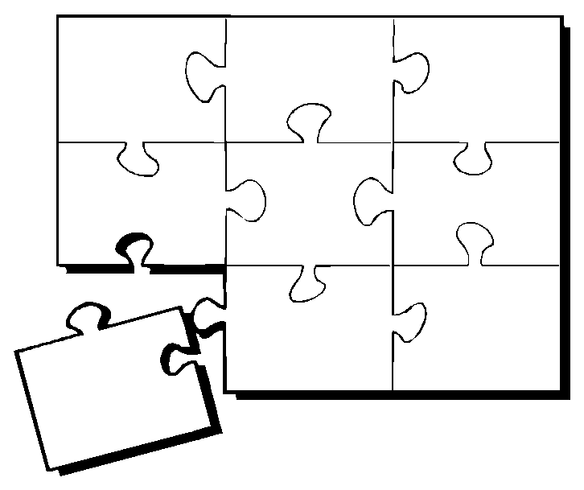
© 1995 TDG, Inc. All rights reserved.
-159-

