"Business on a Page"

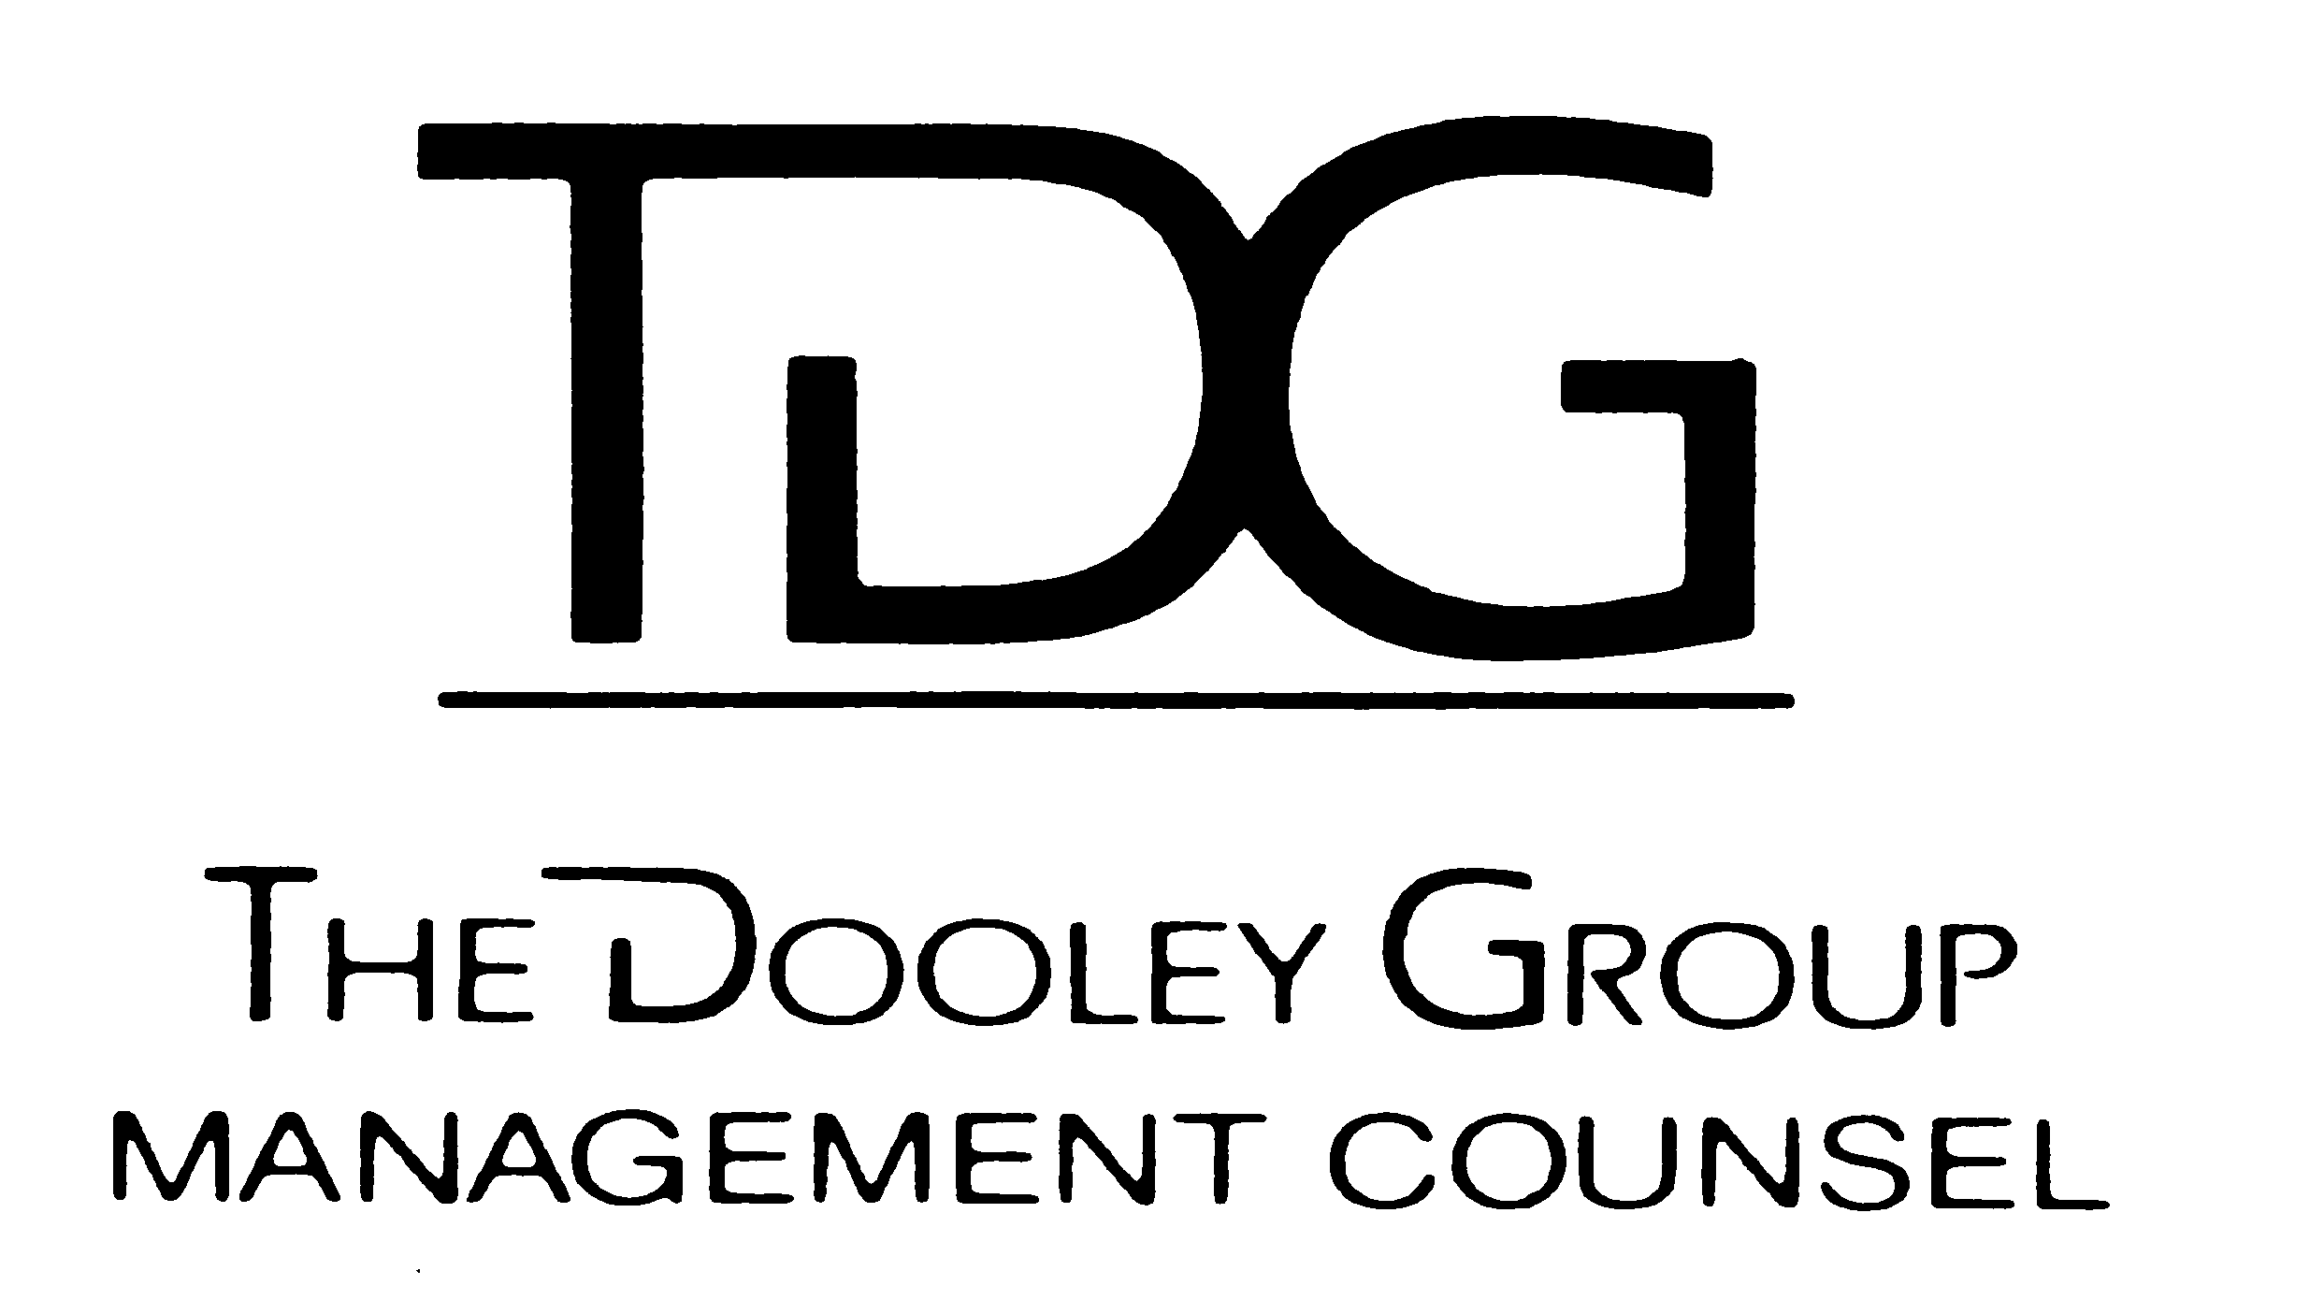
The Dooley Group
Leadership Counsel

Richard E. Dooley has provided personalized, unique and broad counseling to Executive Leadership for over 35 years, across multiple industries, often via a retainer relationship, or during implementation of the below activities. With a diverse network of approximately 50 select organizations, a large portion of which have been closely involved with TDG, Inc. for many years, Dick, as an experienced catalyst, brings about a synergy with significant value for all. Visit the TDG Website (www.thedooleygroup.com) to learn more about, or register for, any of the below.

 | - Leadership Learning Forumsm  (LLFsm) | Created for selected leaders and professionals who have high potential organizational impact. Meets seven times yearly, usually preceded by a half-day orientation session, often meeting at the Keller Graduate School of Management in Lincolnshire, or at a client site. A focus on Host Organizations and sites chosen for their unique insights, products or experiences form a powerful background for our learning and growth. Covering all learning platforms, the LLFSM, in twelve months, provides a very high probability of permanent, desired change by all participants, with superb continual mentoring. An engaged sponsor is a requirement. The TDG Leadership Promise[ see Poster 385] is open to all. This full program has also been adapted and conducted internally on site for, clients.
 | 2. Advanced Leadership Learning Networksm (ALLNsm) | For those Forum graduates with executive level leadership potential, who want to continue growing and learning while expanding in their current responsibilities, we have designed a shortened program, the Advanced Leadership Learning ForumSM (ALLNSM).This includes a customized meeting arrangement, and close guidance by me.
 | 3. Executive Leadership Learning Networksm (ELLNsm) | For very select senior executive level leaders, with whom I connect intensely, this specialized relationship accelerates the learning, growth, change experienced in the above processes, and in attendees' careers afterwards, especially for those aspiring to be successful in a top executive role, with a business, or revenue perspective, as well as traditional staff responsibilities. This also includes a highly customized meeting/presentation arrangement and personal customized counsel with me.
-17-

