A TDG Executive Vignette ™

The reasonable man
adapts himself
to the world.
The unreasonable man
persists in trying
to adapt the world to himself.
Therefore,
all progress depends
upon the
unreasonable man …

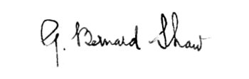

1856-1950

-326-

02/24/03
THE DOOLEY GROUP

