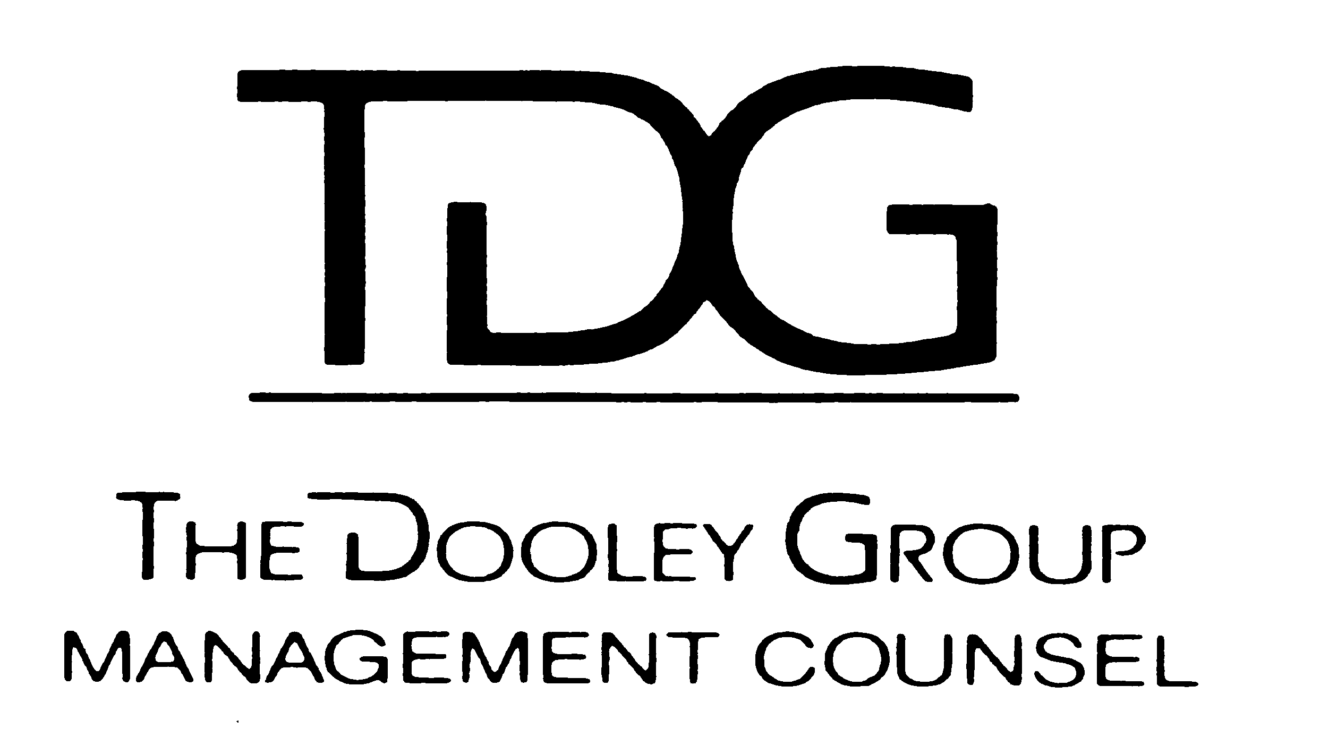  The Dooley Group  Leadership Counsel | Vision  Dick Dooley and TDG, Inc.’s Leadership Series – Vision - Long Term Direction – (i.e., > 3 years)

- Deliver a clear, unique, very rich and intensely valuable opportunity via mutual growth, change and learning for participants, graduates, speakers, Sponsors, Facilitators and “Coaching Mentors” (over c. 6K individually since the inception of the program in the mid `80’s).
- Provide a connection for continued personal exploration, reawakening, self assessment and motivation, for selected individuals within this huge, growing TDG/LLF network.
- Be an alive, changing laboratory for Leadership using as a base TDG’s extensive history and experience with that journey (c. 150).
- Be digital, web-based and face-to-face wherever appropriate.
- Be an effective and efficient framework of TDG, Inc.’s 30 Year Plan (i.e., CRDN30Y on website), use as a powerful communicating/educating vehicle; as a bridge or catalyst so technology and humanity interact positively; to reflect Tai’ Chi flow, balance and unity; to use the Institute Masters’ reputation, stature, presence and base.
-368-

