ENGINEERING TECHNOLOGY DEPARTMENT


ELECTRICAL/ELECTRONIC F19D 10/NAB001

OUTCOME 2

SUMMATIVE ASSESSMENT: VARIANT A

WRITTEN ASSIGNMENT: Identify and use simple electrical/electronic components

Instructions to Candidate
Read this document and carry out all the activities specified.
This assessment covers all requirements for this outcome. There is only one grade of pass and in order to achieve this, a student must pass all parts of this assessment. No part of this assessment carries a numerical score.
Table A: Candidate completes this table.
Candidate’s name:
Class: | Date:

Table B: Marker completes this table.
Marker’s name: |  | Overall result:
Part | 1
Result
Marker’s comments:

Resources
Components, Notes, Powerpoint slides

Identify the components listed below and state an application for each.
Components | Name/Application
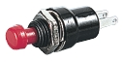
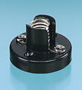
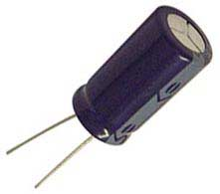
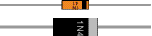

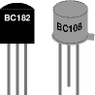

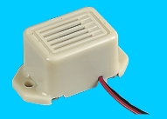



Candidate Name |  | Achieved
Interpret simple specifications
Identify and state use of basic components (any 3 required). | Switches
Identify and state use of basic components (any 3 required). | Lampholder
Identify and state use of basic components (any 3 required). | Protective devices
Identify and state use of basic components (any 3 required). | Resistors
Identify and state use of basic components (any 3 required). | Capacitors
Identify and state use of basic components (any 3 required). | Inductors
Identify and state use of basic components (any 3 required). | Diodes
Identify and state use of basic components (any 3 required). | Transistors
Identify and state use of basic components (any 3 required). | Audio/Visual Devices
Fit basic components  (any 3 required) | Switches
Fit basic components  (any 3 required) | Lampholder
Fit basic components  (any 3 required) | Protective devices
Fit basic components  (any 3 required) | Resistors
Fit basic components  (any 3 required) | Capacitors
Fit basic components  (any 3 required) | Inductors
Fit basic components  (any 3 required) | Diodes
Fit basic components  (any 3 required) | Transistors
Fit basic components  (any 3 required) | Audio/Visual Devices
Security and Integrity of fitted components
Safe working practices observed
Assessor signature and date
Assessor Comment

