Ecto Learning

Discussion Forum Instructions

Visit your Ecto Dashboard and Click “Go to Forum”

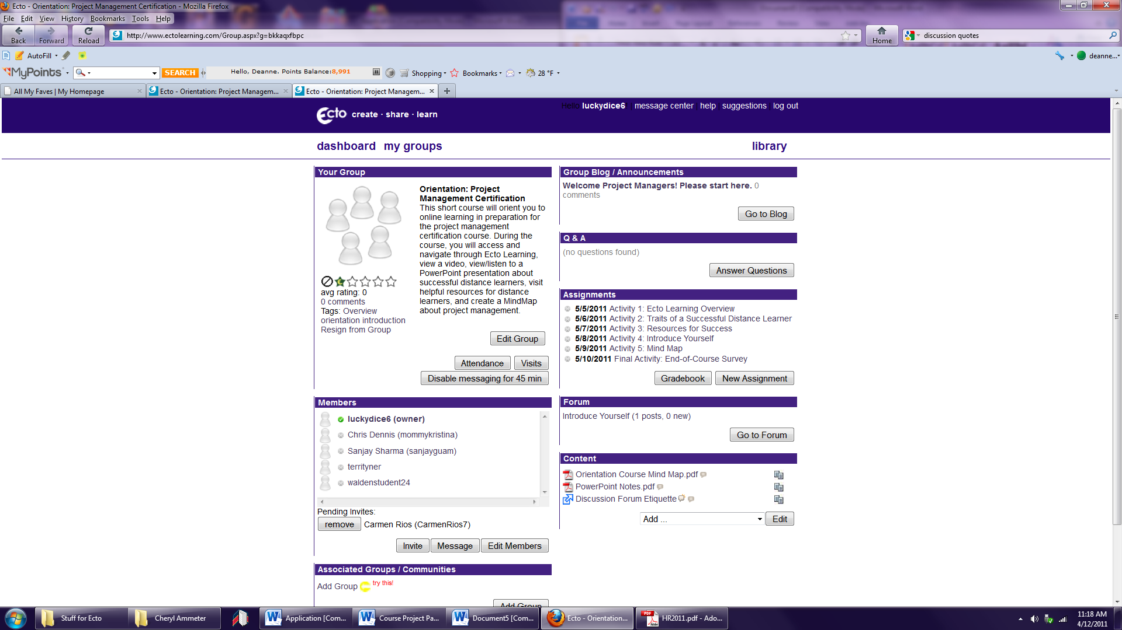

Click the name of the first post to view it.

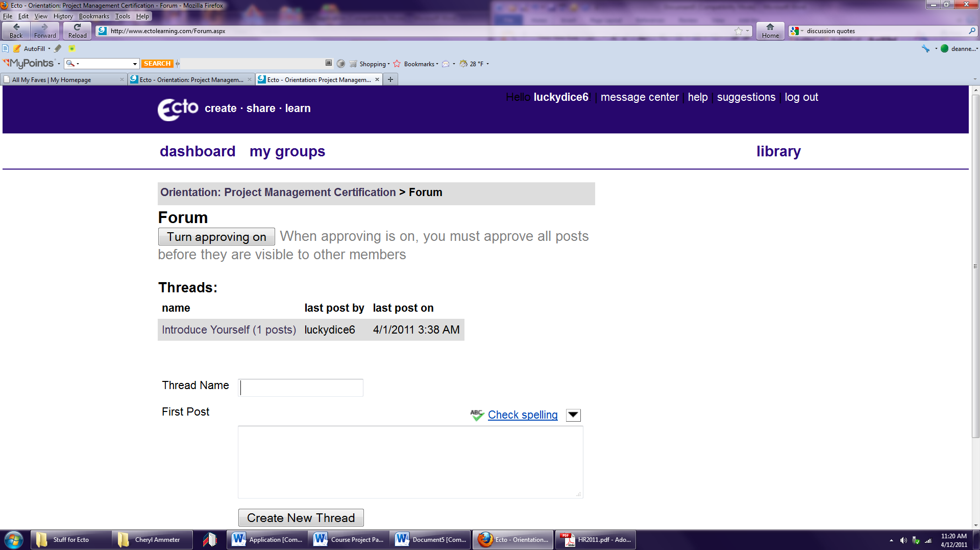

The first message in the thread will open on your screen.

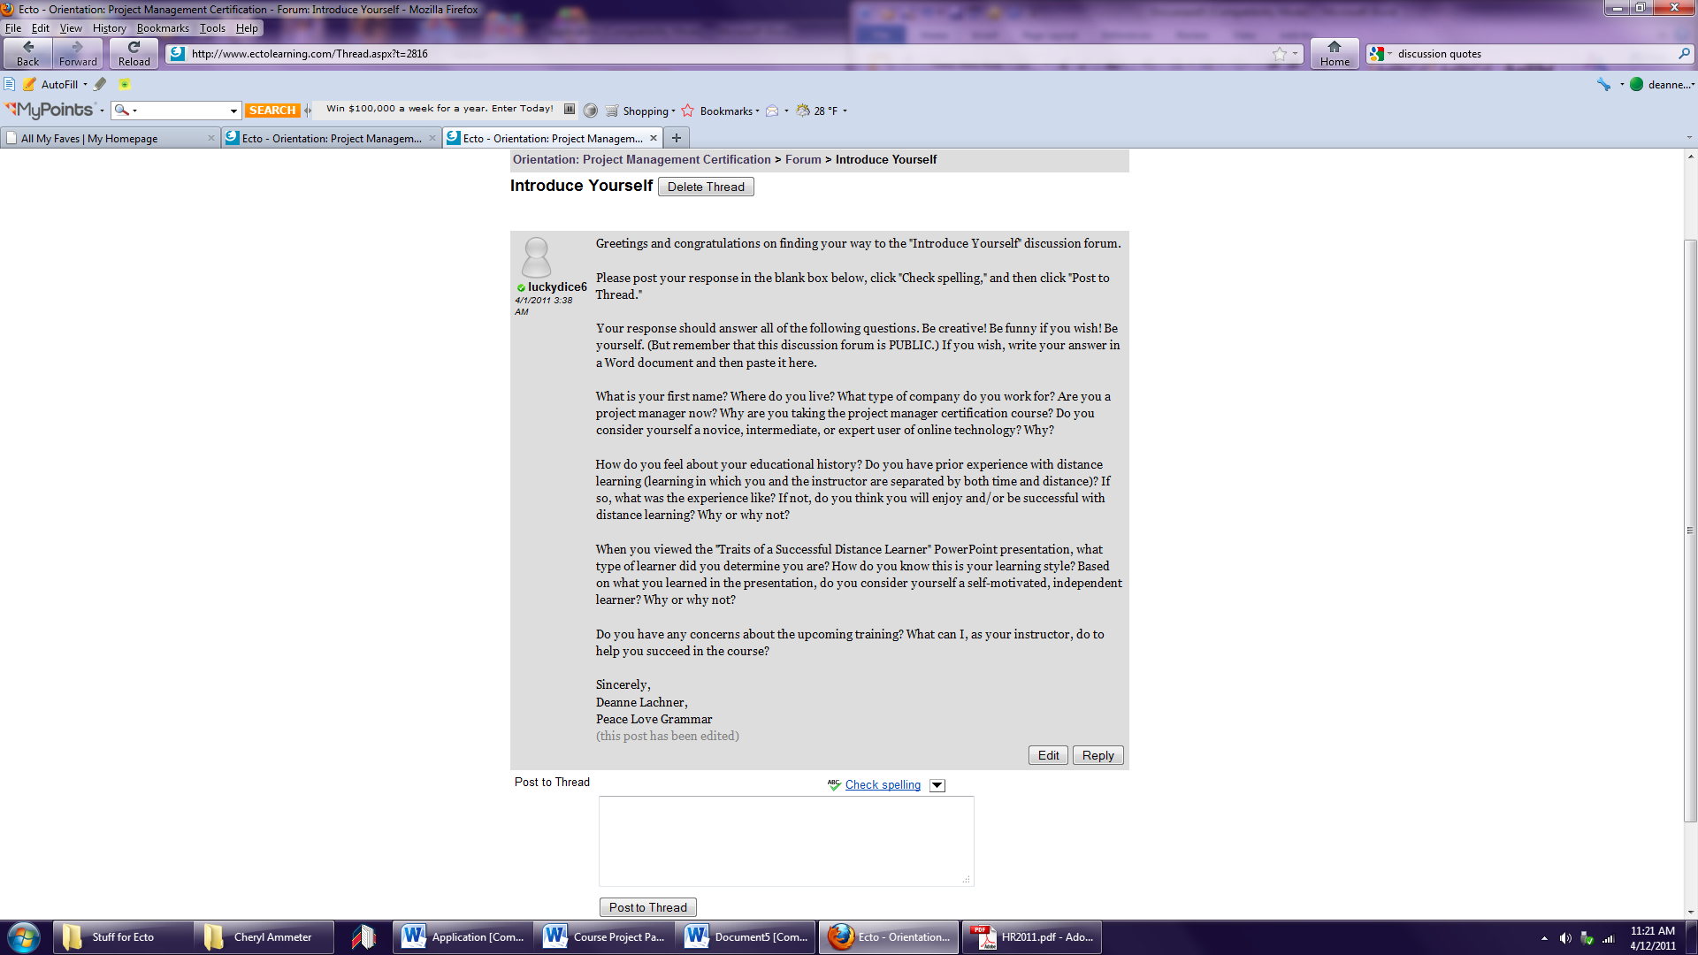

Respond to the post by typing your information into the box below the post. Click “Post to Thread” when you are finished.

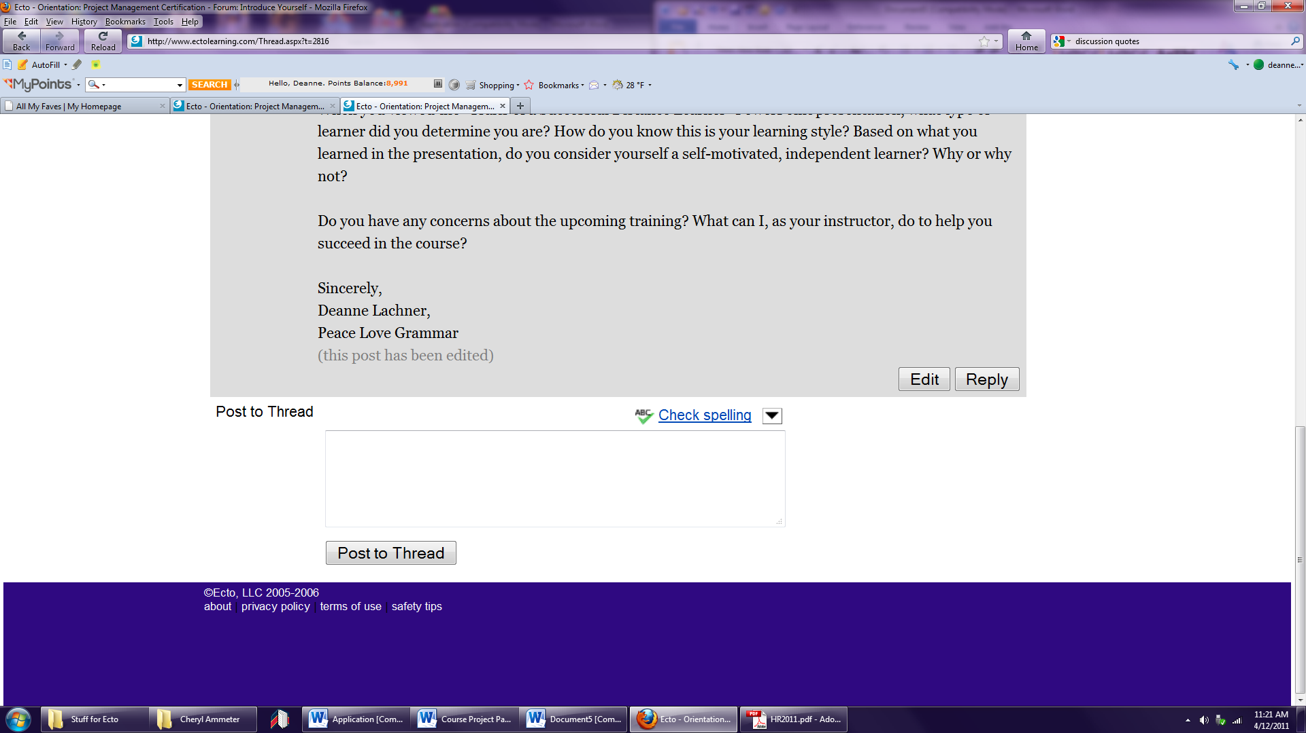
Type your response here.

You’re done!

