A TDG Executive Vignette ™

Quote for LLF Discussion

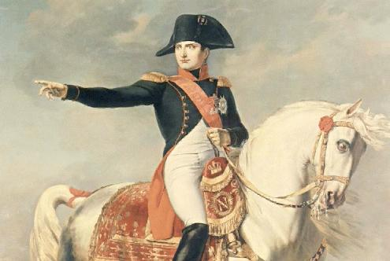
“War is 90 percent
information.”
Napoleon Bonaparte
-314-

07/30/00
THE DOOLEY GROUP

