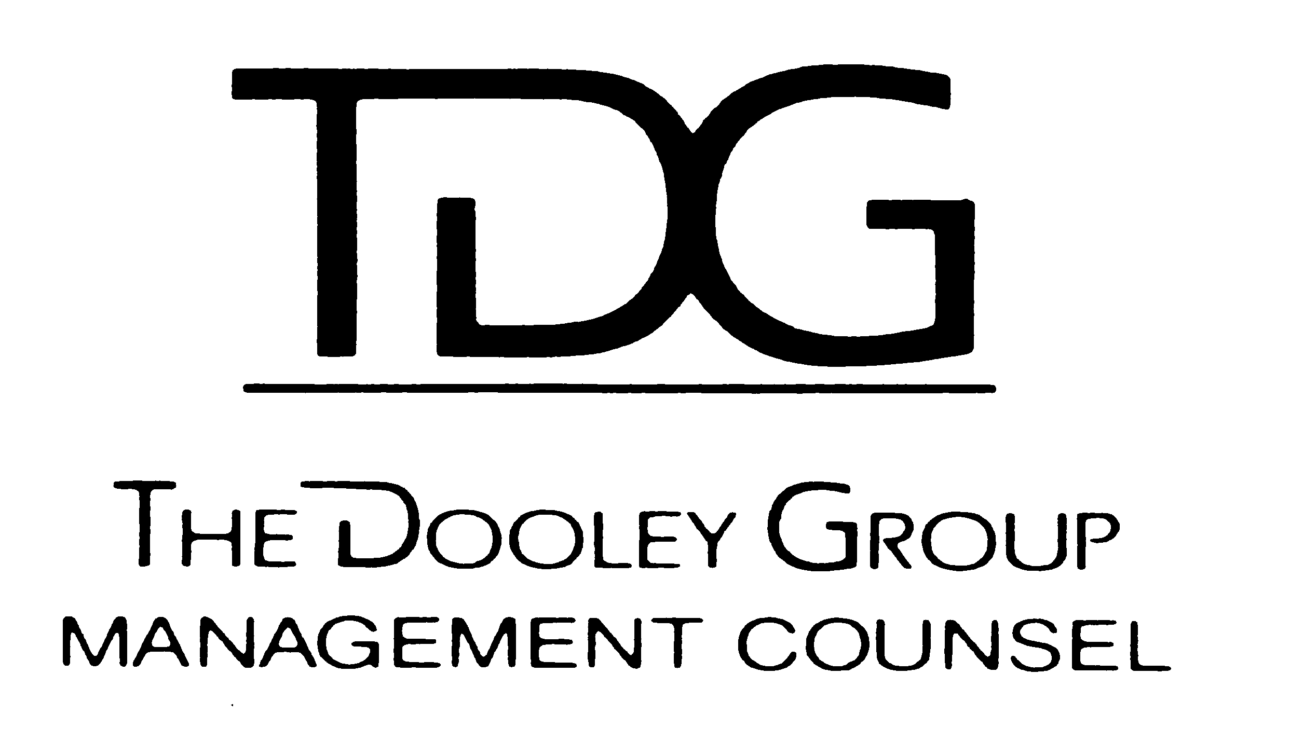  The Dooley Group  Leadership Counsel | TDG, Inc. Leadership Series Advantages/Differentiators  A unique, proven, practical, experience for participants, sponsors, graduates, speakers

- Dick Dooley’s hands on Leadership – Direct, and total responsibility. Quick response. Founder, designer and twenty two year experience with the Forum process. Have led or helped lead c. 200 forums. Copyright materials available on request. Almost 40 years Executive career and connections. Unequalled executive mentoring ability.
- More intense! Seven meetings (starting session, and six consecutive sessions). That’s long enough to learn to learn, and to change, and how to get the work of the future done! And we go to Gettysburg, Saratoga, Cantigny for a “once in a lifetime” Learning and Leadership experience. Also several sessions, each year, are “hosted” by clients on their sites for a unique and deep learning experience.
- Ongoing format. Can start anytime. Flexible scheduling allowed. Reflects current schedules and existing commitments.
- Proven impact on over 3,000 participants via a flexible format, process, style, unique content, tone, and delivery.
- Contents of my Website and Ecto, a web 2.0 SAAS – which includes all LLFSM materials and a history of the forum process, for both new participants, and any graduate
- The experience and presence of Coaching Mentors.
- Huge graduate population (c. 6K) of all TDG LLF’s, the internal client LLF’s, and many SIM RLF’s in which I am involved.
- Networking via TDG, Inc. Speaker Lists, Executive Search List – available to LLF^{sm} participants through TDG, Inc.
- Business/Organizational Impact is the primary focus for every session. Individual & professional growth, learning and change, are also take-away values from every session.
- Common Themes are: Trust and its substitutes; awareness and use of time; technology that’s transparent to but supportive of the business @ hand, generational differences, and personal growth and learning
342

