BUSINESSEXECUTIVE EDUCATION

Lessons From
The Forum

Participants in Lincoln Financial Group’s executive education
forum offer the following advice
to IT managers who would like
to sponsor their own programs:

- Dare to be creative but keep corporate culture in mind.
- Agree upon goals for the program.
- Secure top management buy-in and participation.
- Provide cross-functional networking opportunities.
- Expect executives to put new learning into practice.
On a warm spring day earlier this year, Jeff Albert came from Fort Wayne, Ind., to walk around the Civil War battlefield at Gettysburg, Pa.  It managers in the executive leader-  ship program at Lincoln Financial group find that history has many lessons in leadership that they can apply on the job today.  By Jill Vitiello  Learning  From  History’s Leaders  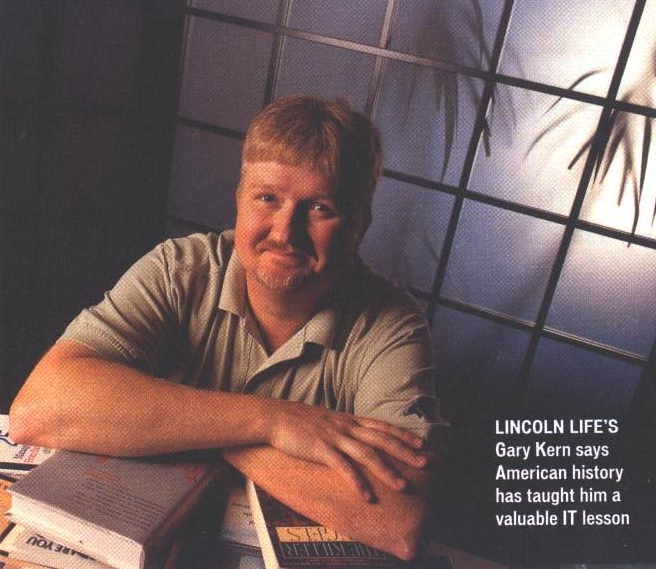  Albert says he was thinking about Col. Joshua Chamberlain's 20th Maine Regiment of Volunteers. On July 2, 1863, they defended the Union flank against charge after charge from Confederate forces up the hill | known as Little Round Top.  "When the soldiers were out of ammunition, they fixed bayonets and ran down the hill. Historians say that unit's courage and commitment to its mission was the turning point of the war," Albert says.  It was a history lesson that Albert says has affected his life today. "I learned that no matter what our title or station in the organization, we can  greatly impact the outcome by committing to our objectives and dutifully carrying them out," says | Albert, second vice president and director of enterprise technology services at Philadelphia-based Lincoln Financial Group.  "Standing right on the spot where Chamberlain fought brought that lesson to life for me," says Gary Kern, assistant vice president and chief technology officer at Lincoln Life and Annuity Company of New York in Syracuse. The information technology leaders were among a group of Lincoln colleagues who had gathered for a special event in an ongoing executive education program known as the Lincoln Leadership Learning Forum.  Leadership Learning  "Lincoln has taken executive education to a higher level than most organizations," says Dick Dooley, founder and president of The Dooley Group Inc., a consulting firm that helped Lincoln develop and implement its program. Dooley is a former CIO and a co-founder of the Chicago-based Society of Information Management.  The forum isn't aimed at pounding technical or management content into executives' brains. Instead, Lincoln's internal program accepts approximately 24 committed participants per year. They meet once per month to discuss the books they are required to read, give and observe presentations on business issues, work on strategic planning, hear guest speakers and attend special events like the one at Gettysburg, Pa.  "I have a 20-year career in IT. I've been to management and leadership classes, and they tend to be technique-focused," says Albert. "The forum is different. It challenges who you are as a person, shakes up your paradigms and fundamentally changes how you operate. It's a sustained program of learning, where the results far exceed what a single class can do."  Now in its fourth generation, the forum "creates a common language and set of experiences for Lincoln executives," says Barbara Taylor, second vice president of employee development at parent company Lincoln National Corp.'s headquarters in Philadelphia.  Forum participants are also required to complete a "give-back" project that enriches the company. The first "class" compiled a book of favorite statements, books and speakers' quotations. The second class built a Web site and database to capture the forum's intellectual capital. The third class created a college-recruitment program and launched a mentoring program to improve retention.  The program has also had a positive impact on the IT organization at Lincoln, according to Albert and Kern.  "As a result of the forum, I | developed a propensity to ask questions and seek feedback. We're  building that into our IT processes so that we stay focused on the needs of our user community," says Albert.  A member of the first forum class, Albert now volunteers as a program facilitator. His continuing involvement has helped him build the mentoring skills that he applies to his own staff members.  "The learning trickles into your own performance and, ideally, improves the performance of the organization," he says.  Kern, a participant in the third class, found the experience immediately applicable to his job. "The forum enhanced my ability to leverage relationships with colleagues from various disciplines throughout the organization and to better understand their views on IT issues," he says.  Commitment to Education  Lincoln's success with the forum is based on a strong commitment to executive education. The company also sends some of its people to university-based executive programs and provides tuition reimbursement for employees.  "It's important to match executive programs and learning to a company's culture," says Taylor. "Executive education should always push an organization, but not at the risk of disconnecting with the company. Lincoln learned this when we created a virtual corporate university called the Center for Breakthrough Business. We came up with a marvelous process and structure, but it was too far out of . . . our corporate culture. It's good for executive education to be progressive, but it has to be connected to what will work in the organization."  Vitiello is a freelance writer in East Brunswick, N.J.

