A TDG Executive Vignette ™

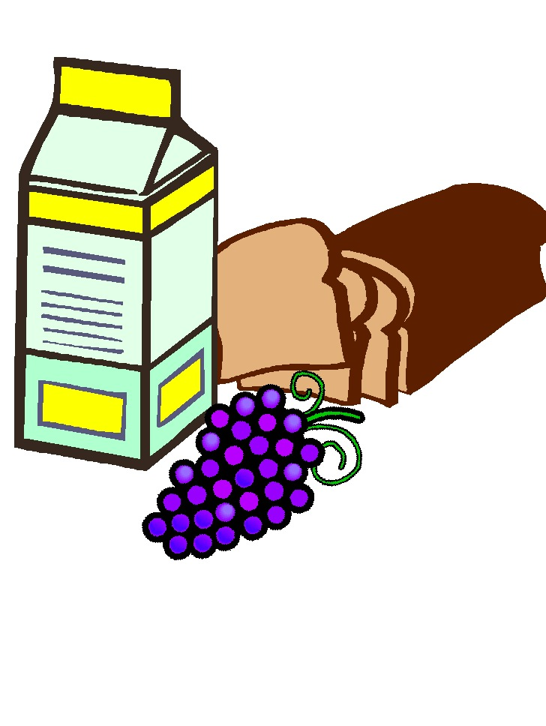
FOOD FOR THOUGHT

- Take on slip of paper with a quote (you can have a second choice).

- Prepare to share with the group your resulting feelings or reactions, or a lesson remembered, or an idea provoked by the quote.

- This sharing should be approximately 45-60 seconds.

- Afterwards we'll discuss the exercise. The context is:

- quick and effective communication,
- resourcefulness/creativity, and
- a fun activity for us all.

-166-
© 1995 TDG, Inc. All rights reserved.

