A TDG Executive Vignette ™

Quote for LLF Discussion

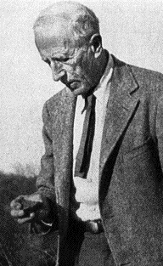
“Remember, we are not human beings having a spiritual experience. We are spiritual beings having a human experience.”

Pierre Teilhard de Chardin

-310-

07/01/00
THE DOOLEY GROUP

