A TDG Executive Vignette ™

Quote for LLF Discussion

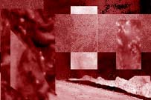
“When the effective leader is finished with his work, the people say it happened naturally.”
- Lao Tse

-315-

07/30/00
THE DOOLEY GROUP

