A TDG Executive Vignette ™

Quote for LLF Discussion

“Be the change you seek to bring about in others.”

M.K. Gandhi
1869-1948
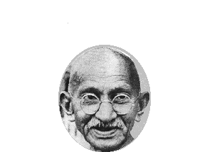

(From the top through first level managers)

-323-

05/05/04
THE DOOLEY GROUP

