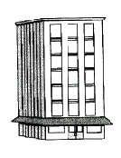
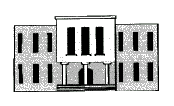




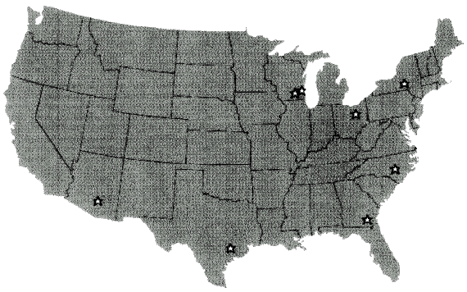

Larry Cinpinski –Midwest RLF ’94
16.2

Miller Brewing Company Fact File

- Part of Philip Morris Companies
- #2 Brewer in the World
- 45 MM BBLS Annual Volume
- $4.0 Billion Annual Sales
- 96% of sales are domestic

(8) Breweries

- Brew, Package, Ship
- 53 MM BBL Capacity
- 26 Brands
- 1500 SKU’s

Corporate

- F&A
- Legal
- IS
- Engineering
- Purchasing
- HR
- Order Planning
- Production Planning
- Sales and Marketing
Production Plan
Orders
(686) Distributors
- (680) Independent
- (6) Miller owned

Retail

Finished Goods -
- Forecast
- Orders
43% of sales
26% of production
57% of sales
74% of production

