Name _____________________________ |  |  | Date ___________________
To the nearest tenth, find the circumference. Use 3.14 for .
  1.
    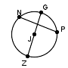
       | = | 37 | ft
        ZJ
  2.
    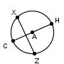
       | = | 10 | cm
        CH
  3.
    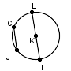
       | = | 88 | in
        TL
  4.
    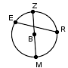
       | = | 61 | mm
        BZ

Find the circumference. Use |  | for .
  3.14

5.
  radius = |  | cm
    13
  6.
    diameter = |  | ft
      20
  7.
    diameter = |  | mm
      3
  8.
    radius = |  | in
      26
To the nearest tenth, find the area of each circle. Use 3.14 for .
9.
  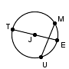
     | = | 22 | in
      TE
  10.
    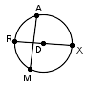
       | = | 3 | mm
        DR
  11.
    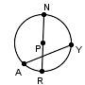
       | = | 40 | ft
        RP
  12.
    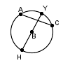
       | = | 19 | cm
        HY
ey #2

To the nearest tenth, find the area of each circle. Use 3.14 for .
  13.
    diameter = | 22 | mm
  14.
    radius = | 11 | in
  15.
    diameter = | 25 | ft
  16.
    radius = | 9 | cm
To the nearest tenth, find the area of each circle. Use 3.14 for .
17.
  radius = | 6.541 | ft
  18.
    diameter = | 44.4 | cm
  19.
    diameter = | 25.43 | in
  20.
    radius = | 38.7 | mm
y #2

Complete.
  21. | If the base of a rectangle is 24.3 cm and the area is 580.77 cm², what is the height of the rectangle?
  22. | What is the perimeter of a parallelogram with base 9 cm, side length 27 cm, and height 20 cm?

  23. | If the height of a rectangle is 9 3/4 m and the base is 5 3/5 m, what is the perimeter of the rectangle?
  24. | If the height of a rectangle is 1 1/4 m and the base is 6 1/2 m, what is the area of the rectangle?

  25. | The perimeter of a rectangle is 40 m. The base is four less than five times the height. What is the height?
  26. | The area of a rectangle is 243 m². The height is nine less than four times the base. What is the perimeter?
Key #2
  27. | What is the height of a triangle with base 28 m and area 406 m²?
  28. | What is the area of a triangle with base 15 cm and height 24 cm?
  29. | What is the length of the base of a triangle with height 10 m and area 23 1/3 m²?
  30. | What is the area of a triangle with base 3 1/5 m and height 3 m?
Find the area of each parallelogram.
  31.
    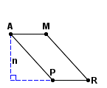 | n = 47 mm
       | = | 36 mm
        AM
       | = | 64 mm
        AP
  32.
    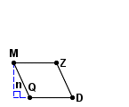 | n = 30 cm
       | = | 37 cm
        QD
       | = | 33 cm
        DZ

Find the area of each parallelogram. Round your answer to the nearest tenth.
  33.
    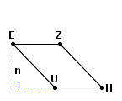 | n = 5.2 mm
       | = | 7.2 mm
        EU
       | = | 5.6 mm
        EZ
  34.
    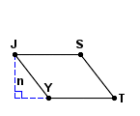 | n = 14.3 in
       | = | 21.5 in
        YT
       | = | 18.1 in
        TS

Find the area of each parallelogram.
  35.
    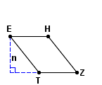
       | = | 27 | cm
        EH
      n = |  |  |  | cm
        25
          1
          2
       | = |  | cm
        ET
        32
          1
          2
  36.
    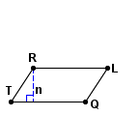
       | = |  | in
        RT
        9
          1
          3
       | = |  | in
        RL
        17
          1
          9
      n = |  |  |  | in
        7
          7
          9
Find the area of each triangle.
37.
  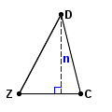 | n = 85 ft
     | = | 88 ft
      CD
     | = | 66 ft
      ZC
     | = | 96 ft
      ZD
  38.
    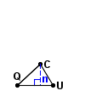 | n = 17 cm
       | = | 19 cm
        UC
       | = | 25 cm
        QC
       | = | 28 cm
        QU
Key #2
Find the area of each triangle. Round your answer to the nearest tenth.
  39.
    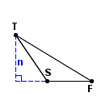 | n = 1.1 in
       | = | 1.4 in
        ST
       | = | 1.1 in
        SF
       | = | 2.2 in
        FT
  40.
    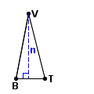 | n = 3.1 cm
       | = | 3.2 cm
        BV
       | = | 1.4 cm
        BT
       | = | 3.2 cm
        TV
Find the area of each triangle.
  41.
    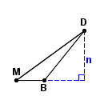
      n = |  |  |  | cm
        41
          1
          3
       | = | 70 | cm
        MD
       | = |  | cm
        MB
        23
          1
          3
  42.
    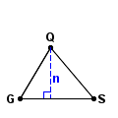
      n = |  |  |  | ft
        17
          1
          3
       | = |  | ft
        SQ
        22
          2
          3
       | = | 25 | ft
        GS

