A TDG Executive Vignette ™

" God grant me the serenity to accept the things that I cannot change.
The courage to change the things that I can.
And the wisdom to distinguish the one from the other. "
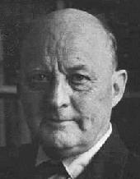

Reinhold Niebuhr, 1892-1971
American Theologian

-376-

