A TDG Executive Vignette

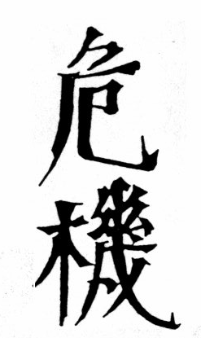

When an organization or an individual is faced with adjusting to increasing change, a crisis situation often develops. As shown above, the Chinese have a revealing way of expressing CRISIS. The upper character represents danger, while the lower one conveys hidden opportunity. Leaders or Managers responsible for implementing organizational change within their organization have the same options the Chinese symbols suggest: dangerous negative results or positive new opportunities. Both exist together - where you see one, look for the other, and learn to appreciate, respond to both, with balanced objectivity.

11/2/93
THE DOOLEY GROUP
-33-

