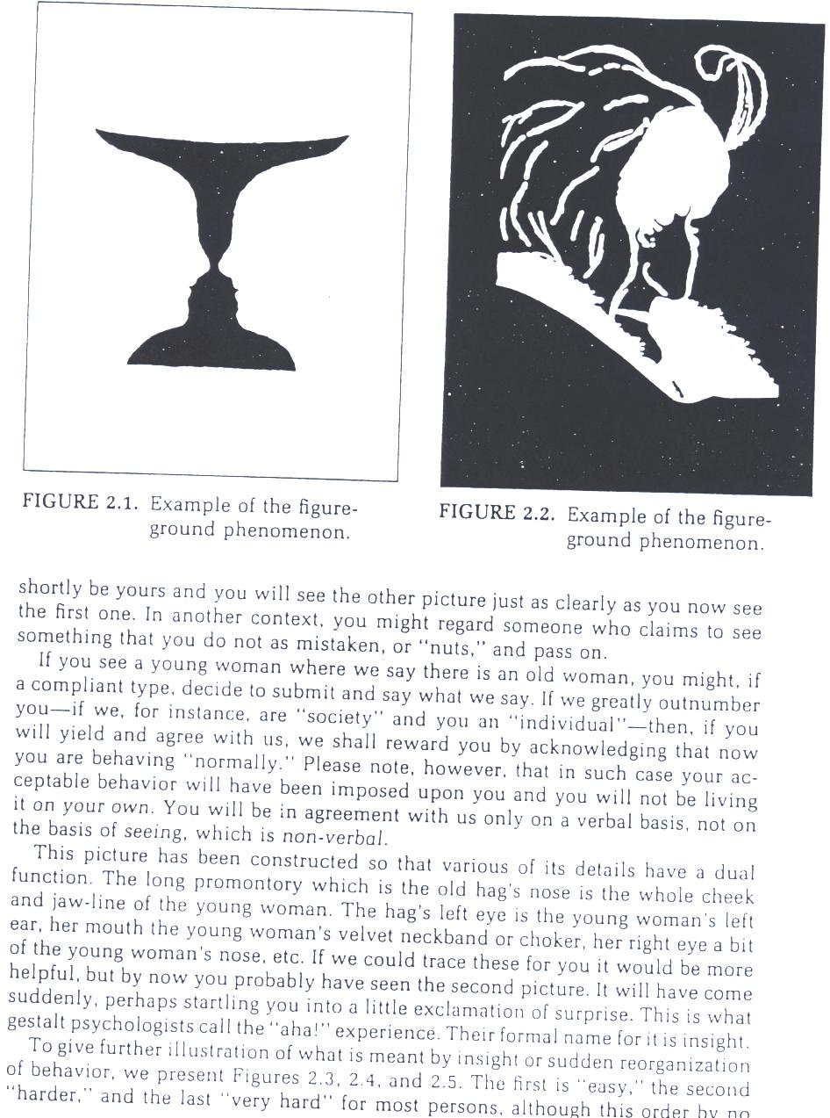
shortly be yours and you will see the other picture just as clearly as you now see the first one. In another context, you might regard someone who claims to see something that you do not as mistaken, or “nuts,” and pass on.

If you see a young woman where we say there is an old woman, you might, if a compliant type, decide to submit and say what we say. If we greatly outnumber you – if we, for instance, are “society” and you an “individual” – then, if you will yield and agree with us, we shall reward you by acknowledging that now you are behaving “normally.” Please note, however, that in such case your acceptable behavior will have been imposed upon you and you will not be living it on your own. You will be in agreement with us only on a verbal basis, not on the basis of seeing, which is non-verbal.

This picture has been constructed so that various of its details have a dual function. The long promontory which is the old hag’s nose is the whole cheek and jaw-line of the young woman. The hag’s left eye is the young woman’s left ear, her mouth the young woman’s velvet neckband or choker, her right eye a bit of the young woman’s nose, etc. If we could trace these for you it would be more helpful, but by now you probably have seen the second picture. It will have come suddenly, perhaps startling you into a little exclamation of surprise. This is what gestalt psychologists call the “aha!” experience. Their formal name for it is insight.

To give further illustration of what is meant by insight or sudden reorganization of behavior, we present Figures 2.3, 2.4, and 2.5. The first is “easy,” the second “harder,” and the last “very hard” for most persons, although this order by no

