A TDG Executive Vignette ™

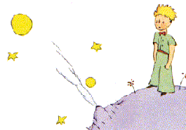

“And now here is my secret, a very simple secret; it is only with the heart that one can see properly; what is essential is invisible to the eye.”

Antoine de Saint-Exupéry, 1900-1944
French Novelist and Aviator


-388-

