A TDG Executive Vignette ™

A century ago the Swiss historian Jacob Burckhardt foresaw that ours would be the age of
"The great simplifiers", and that the essence of tyranny has the denial of complexity.
He was right.

This is the single great temptation of the time.
It is the great corrupter, and must be resisted with purpose and with energy.
What we need are great complexifiers, men who will not only seek to understand what it is
they are about, but who will also dare to share that understanding with those for whom they act.
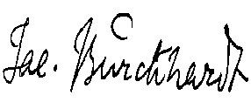

-306-

04/18/00
THE DOOLEY GROUP
© 2000 TDG, Inc. All rights reserved.

