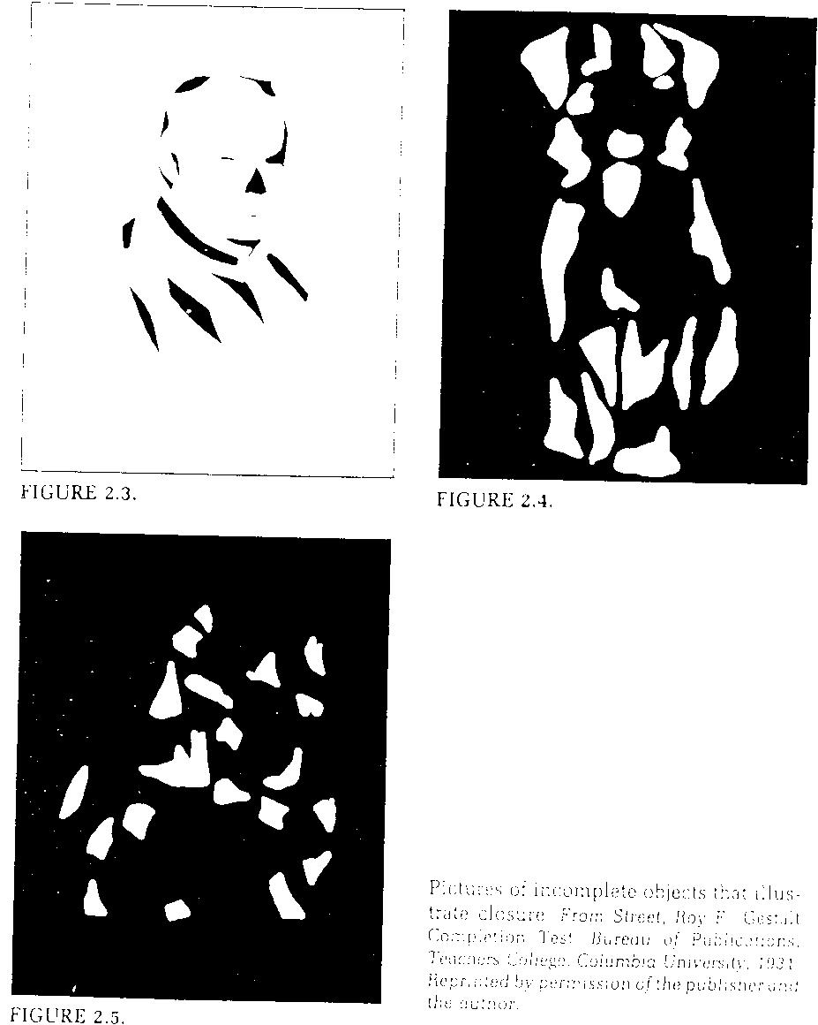
Pictures of incomplete objects that illustrate closure. From Street, Roy F. Gestalt. Completion Test. Bureau of Publications, Teachers College, Columbia University, 1931.
Reprinted by permission of the publisher and author.

